**Create ETO and My Inbox Testing Guide (NON HPS ONLY)**

**Using The User ID for Inside Sales** : TESTUSER20

**Created Sales Order :**15186626

Relevant users will have access to the following two tiles namely

* Create ETO (Inside Sales)
* My Inbox (The different Individuals/groups involved in processing the orders ex App Engg.etc)

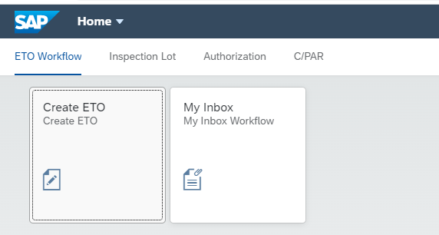

**Create ETO Screen**

Clicking on the Create ETO Tile will bring the user to the screen below

User will input the sales order number and press GO button.

If an invalid sales order number is entered, there will be an error message

Request status will be defaulted to “New”

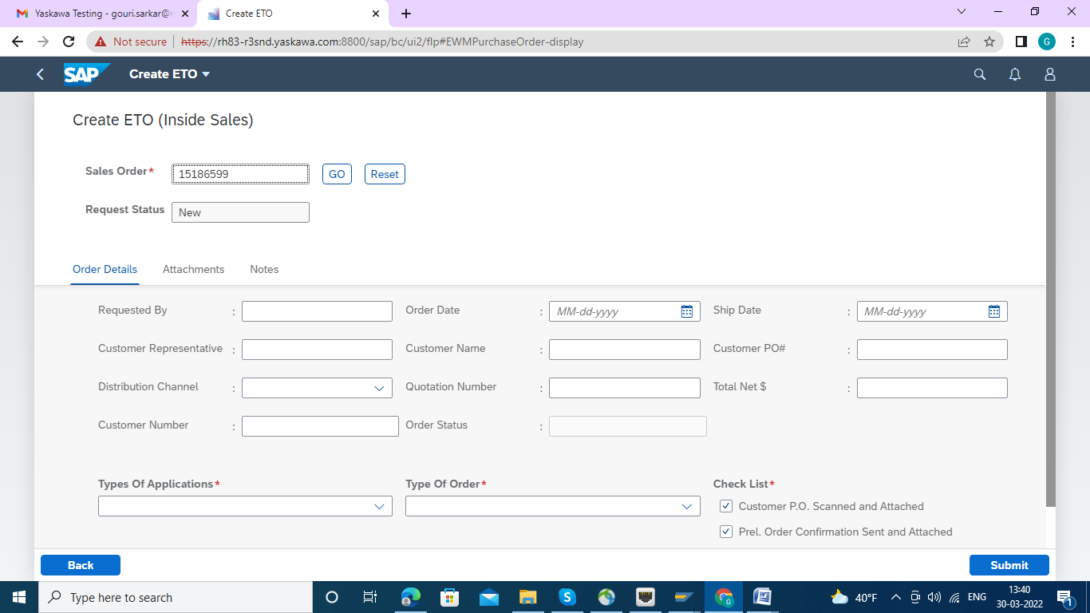

In this process , Any sales order was already procecessed the execution wil be appeared as this .

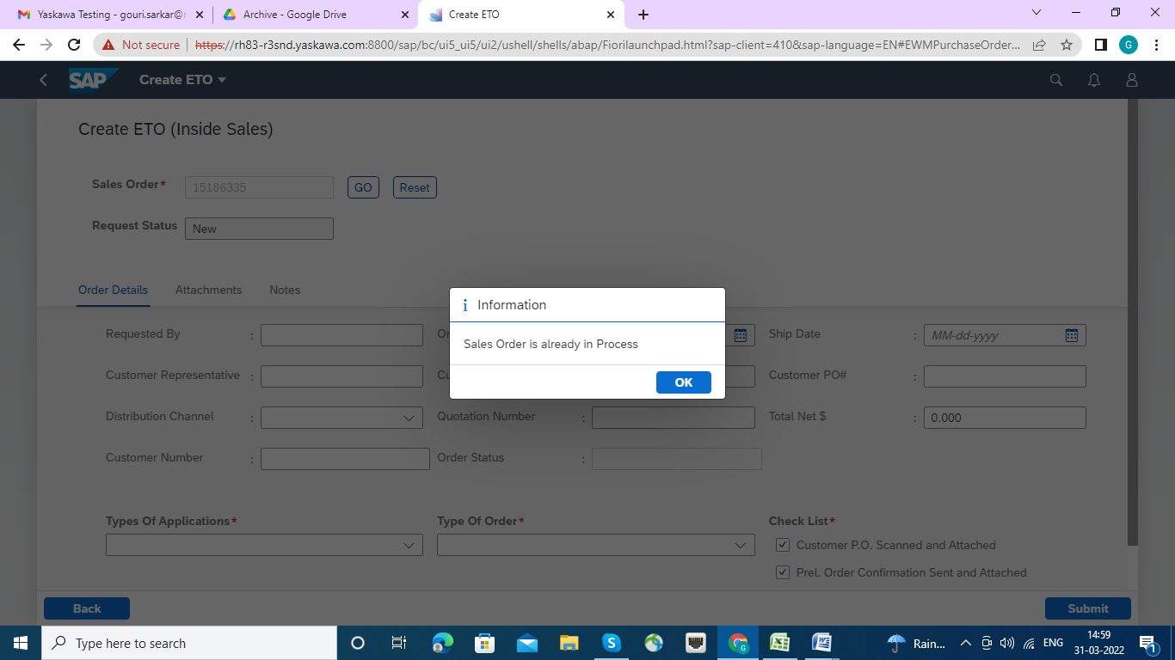

And Wrong Sales order will be executed like this.

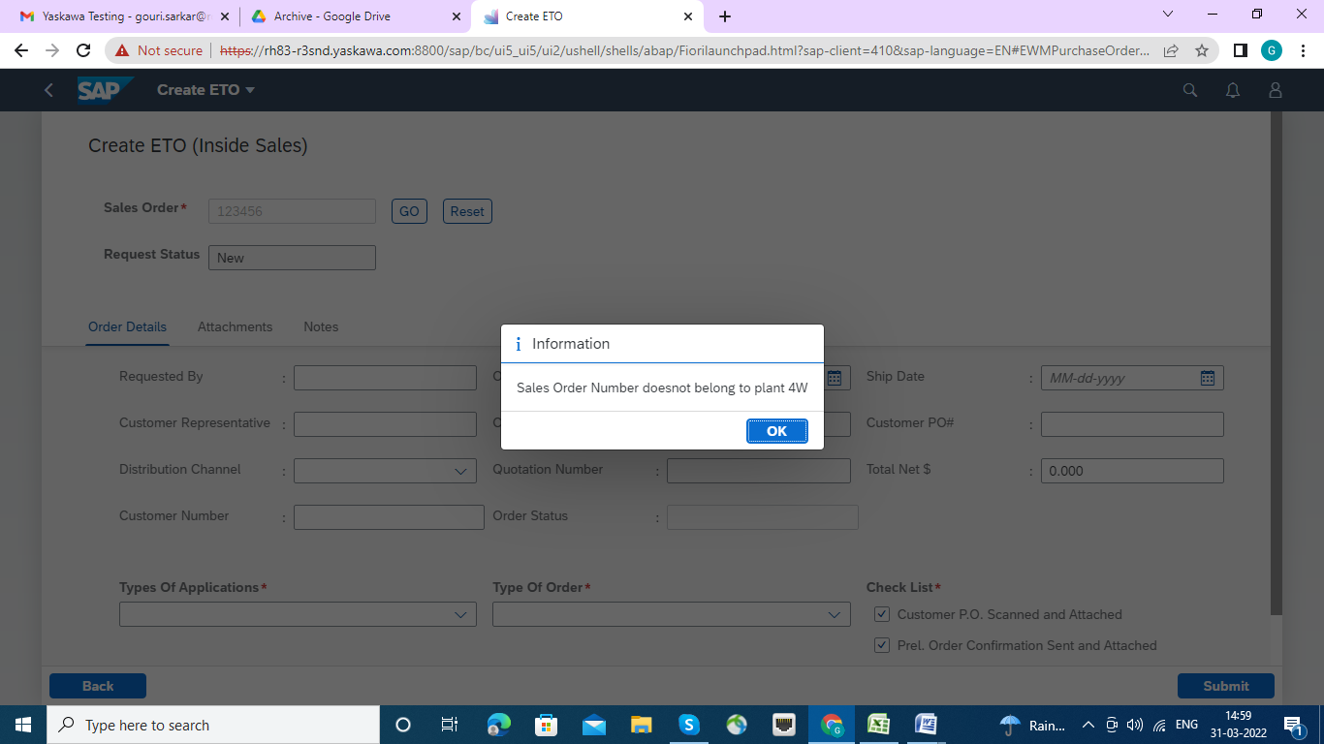

On Successful entry of a Sales Order, the details of the SO will be displayed in the screen with the following tabs

* Order Details
* Attachments
* Notes

**Order Details Tab:** User can edit the fields as required. For ex. to change the Ship Date, Distribution channel etc

Note: Please insert "Quotation Number" : if It will be given , otherwise left it with Blank. While inserting Quotation No. no parenthesis is applicable here.

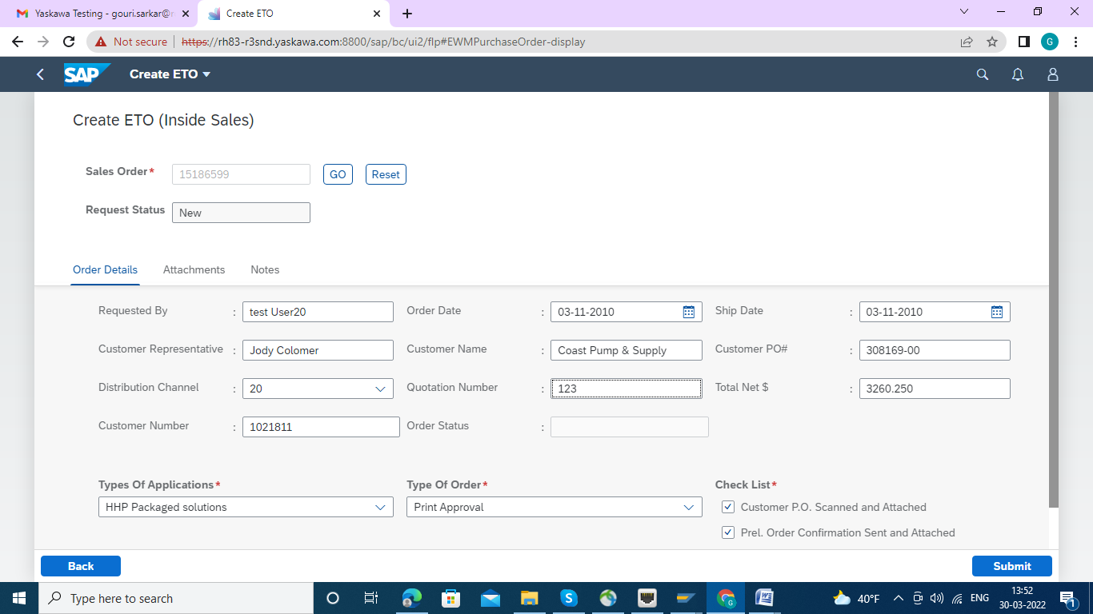

Then Click on:

**Attachment Tab :**All the documents that are part of the initial Sales order will be displayed

User has option to add the new attachment by clicking on the “Add Attachment” button.

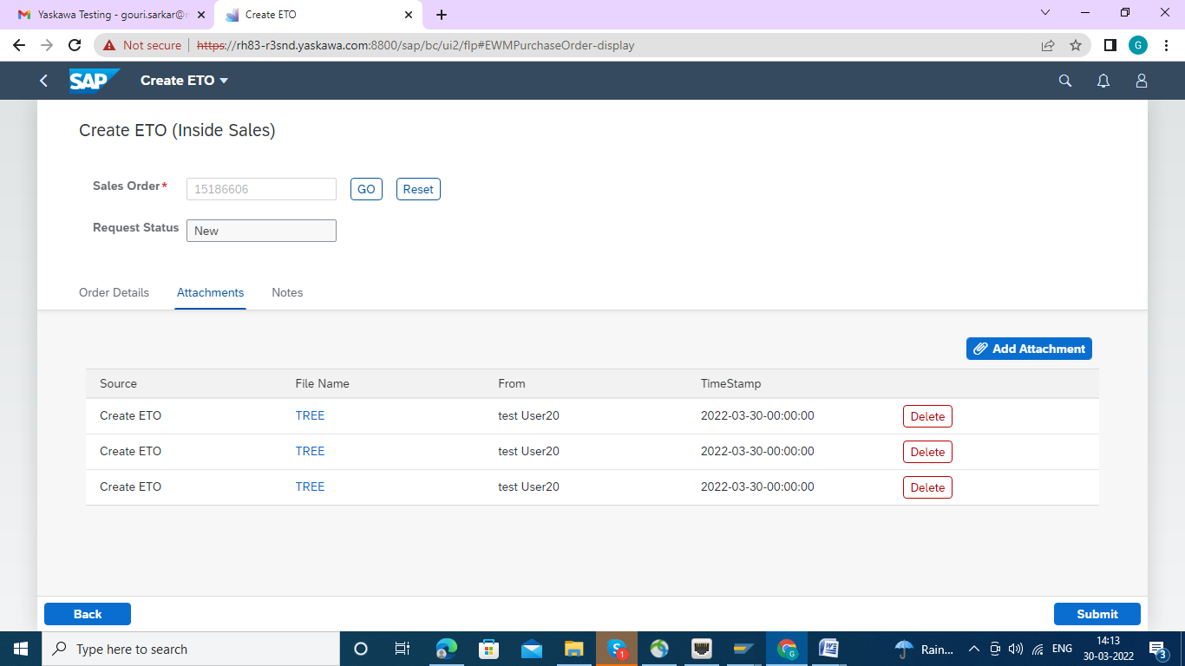

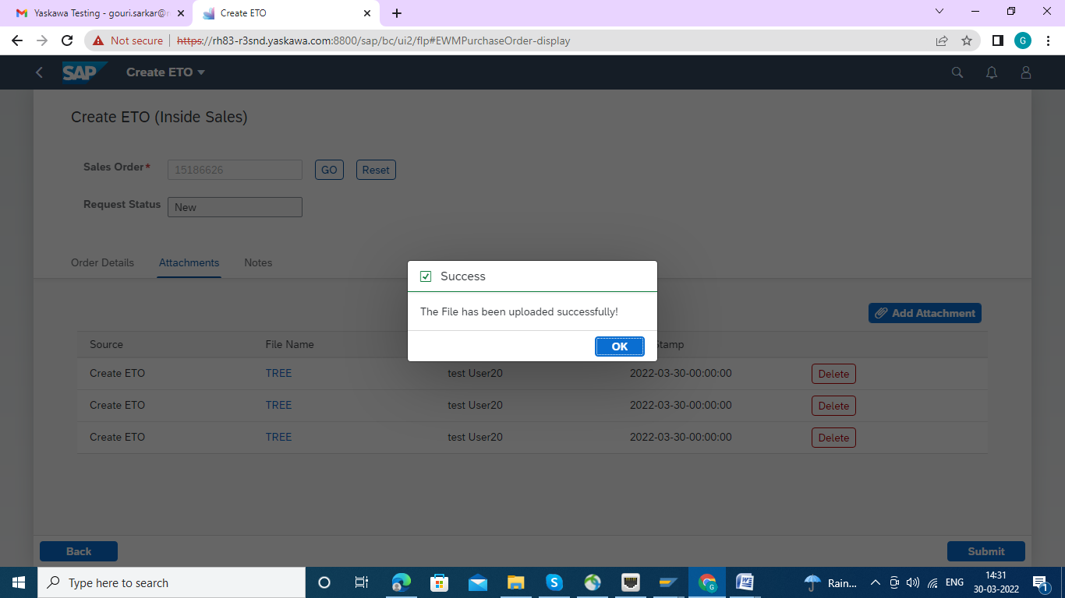

**Notes Tab:** User can add additional notes in this tab in the field provided for notes

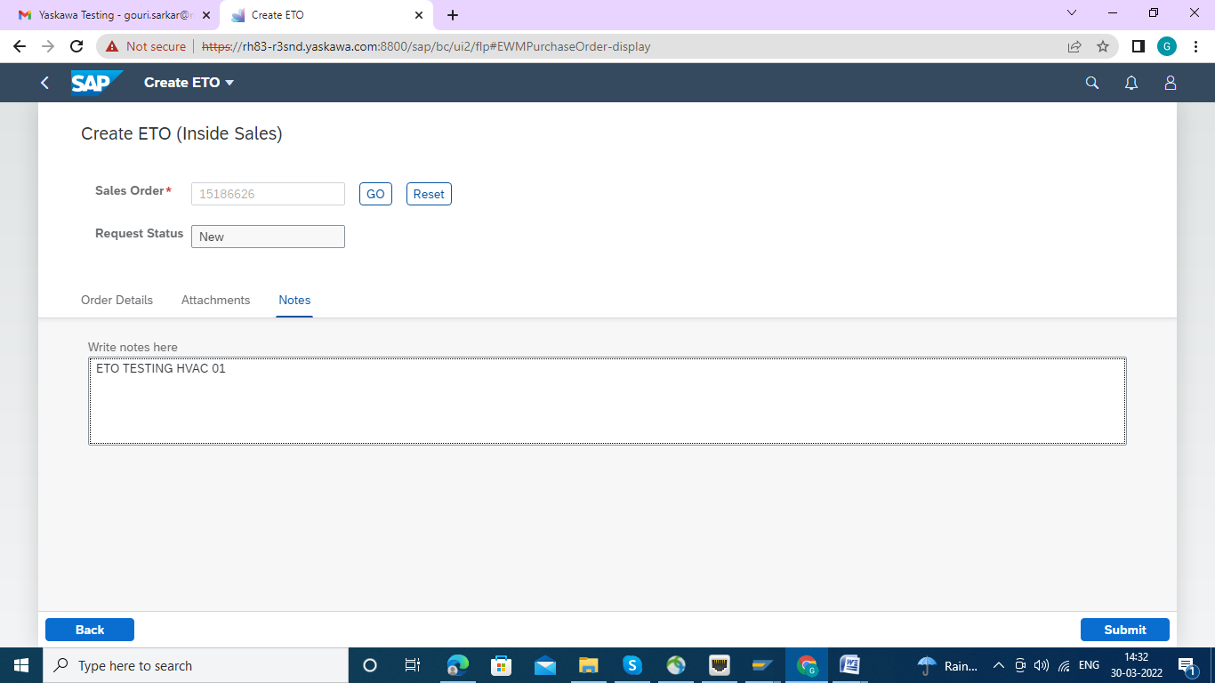

**Create ETO (WorkFlow Trigger)**

In the order details tab User can select the options in the following fields (Drop down menu highlighted)

- Type of Application

- Type of Order

Once Submit button is pressed Email notification will be sent to the respective Engineering department based on combinations and one general notification will be created in the backend.

Selecting Here :Types of Application as "Commercial Type (HVAC)" and Type of Order as "Print Approval" as this ETO is making for non HPS.

Marked the Check List as applicable.

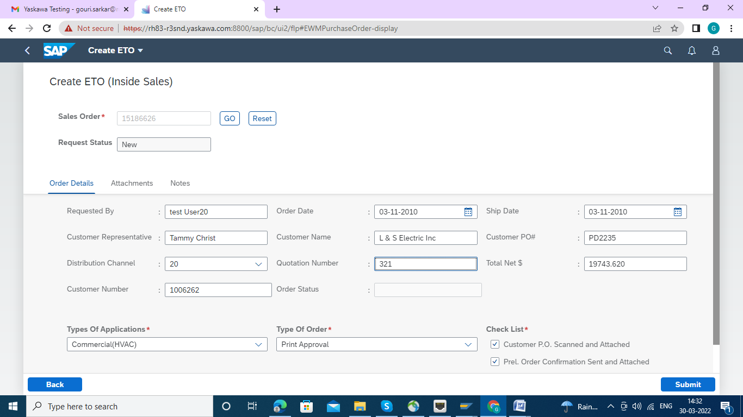

Now Press the "Submit" Button and the Message has come that Notification No. has generated and that no. has been sent to the APP Engineer HPAC Group via Email.

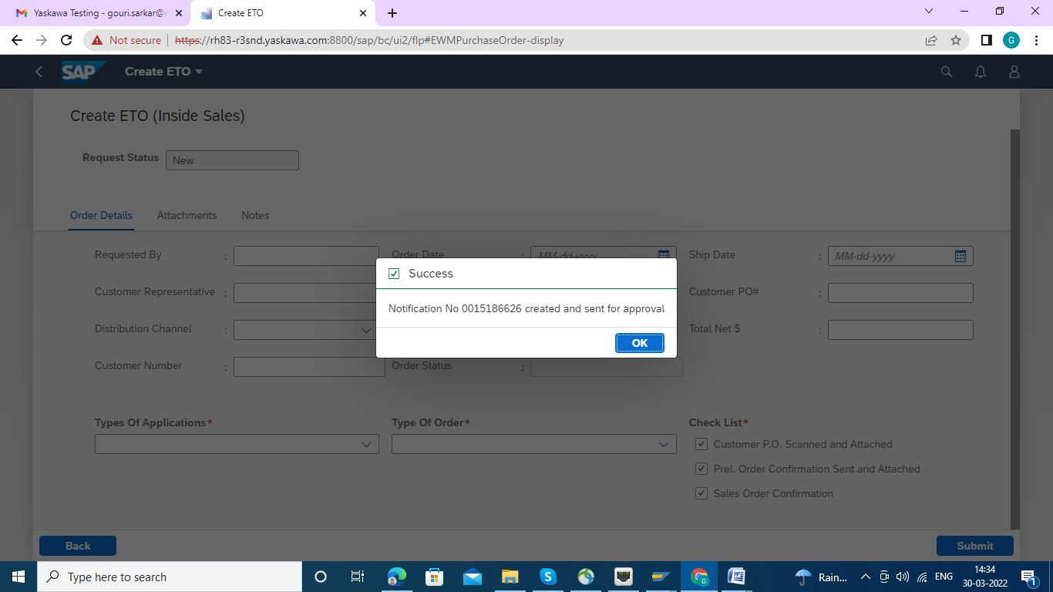

**MyInbox Testing Guide**

This Test has been conducted as "APP Engineer HVAC" , using the User ID: TESTUSER23 , , and Sales Order 151866626, which was created earlier through ETO by Inside Sales.

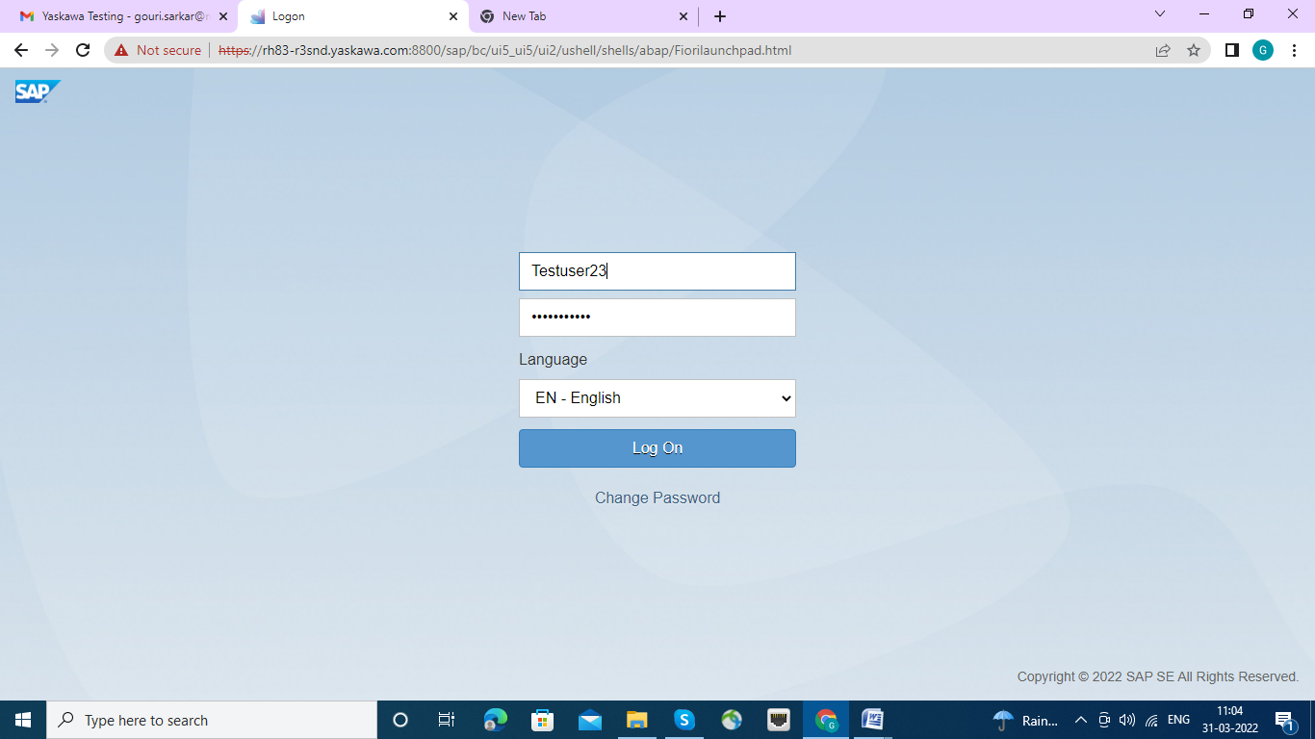

After login ,the below screen appeared.

Clicking on the My Inbox Tile will navigate to the “My Inbox screen”

All the Sales orders which are triggered from the Create ETO screen to a particular person will be visible in this Screen

User can also search and filter for SO’s assigned to other users or groups

For ex : SO1,SO2 are triggered to **User A** , when **User A** opens the my Inbox with his/her login credentials then SO1 and SO2 will be visible to him/her .

Along with that there are also different filter options where user can filter the values and see other Sales orders based on the filter value.

The red highlighted box will be for filter/search values. The SO details will be shown below the filter box with distinct Sales Order details.

This will show list of distinct Sales order number with header details.

User can select the SO/SOs and has option to reassign or accept the SO for further processing

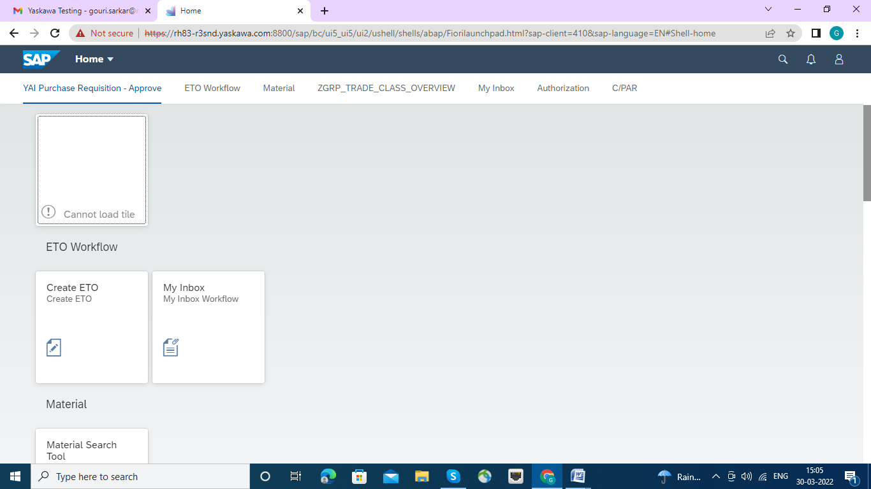

Double click on "My Inbox" the "ETO-MyInbox" page has been opened up

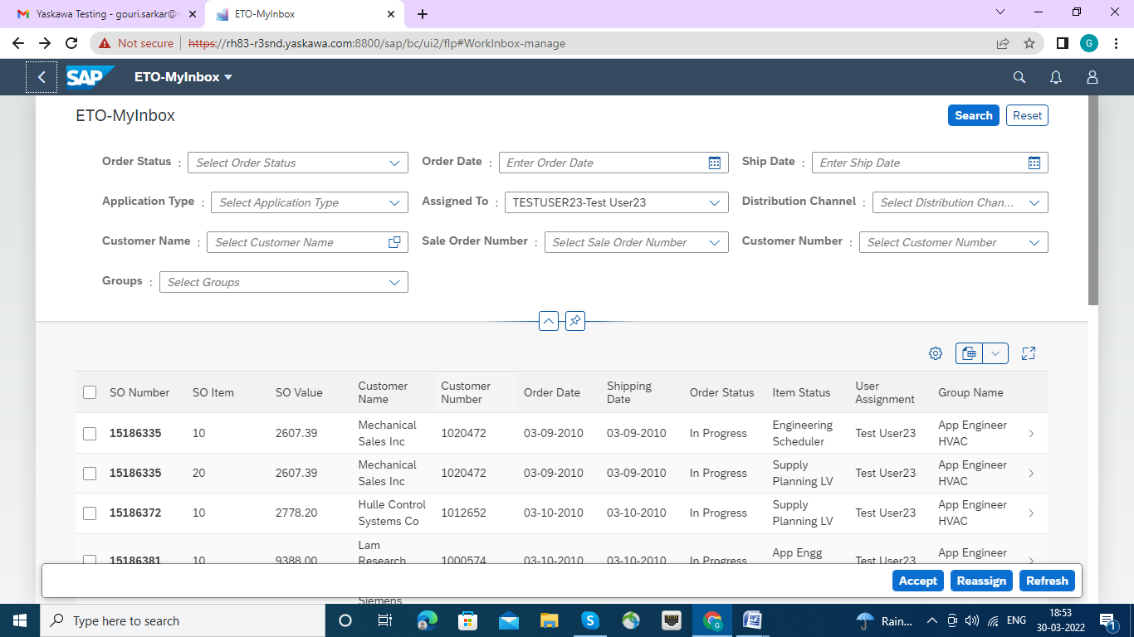

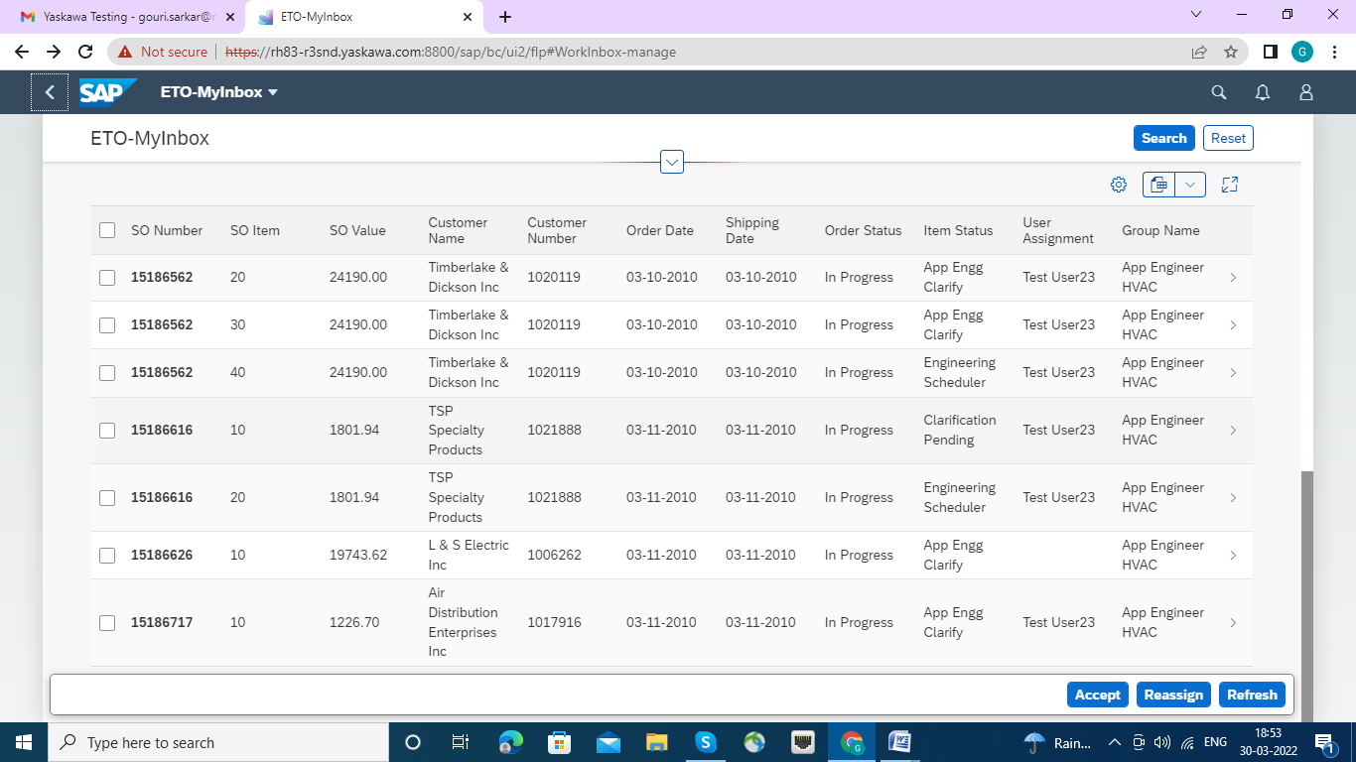

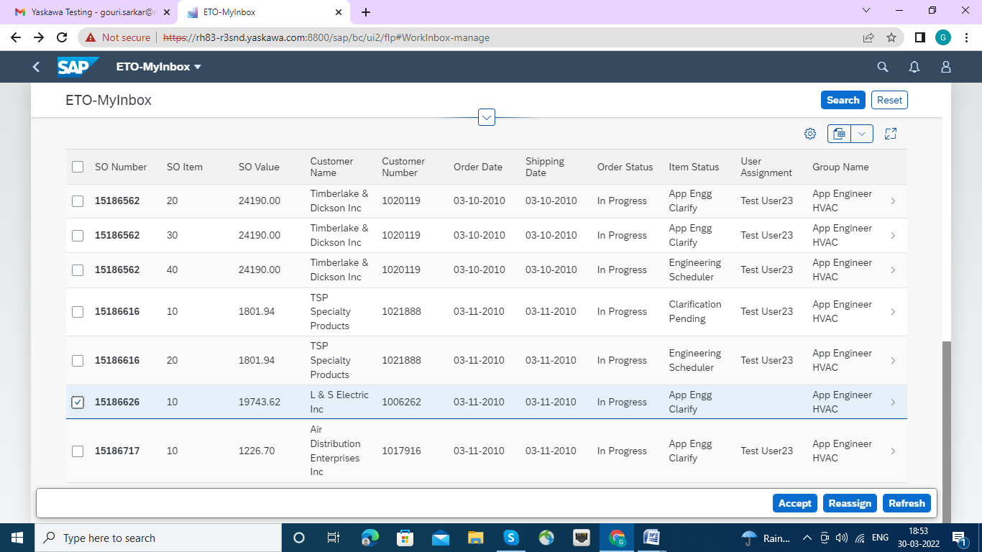

**Reassign**

If user chooses to reassign one or more SO to a particular group or individual, the selected Sales Order/Orders will be updated with the assigned person/Group name and intimation mail will be sent to inform them that the Sales Order/Orders are assigned to them.

Screen shot shows when the reassign button is pressed the option to select Individuals/Groups. If a user is selected then the groups to which he available will be shown in the drop down. Or else a particular group can be assigned without assigning an individual

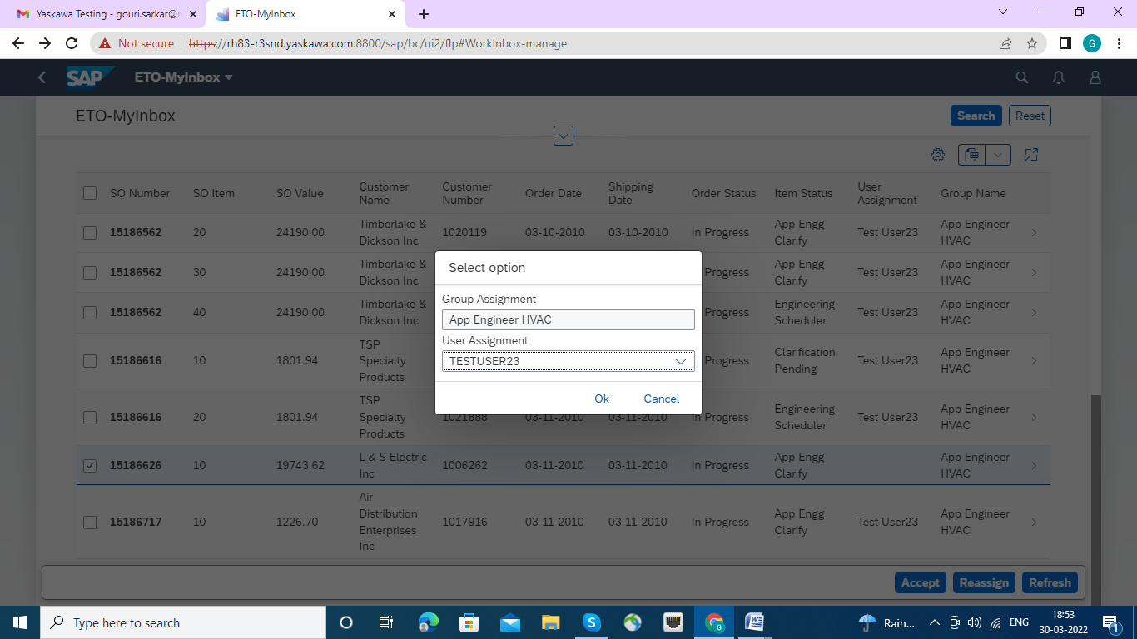

After assign user Assignment and click on OK button , Message displayed success .

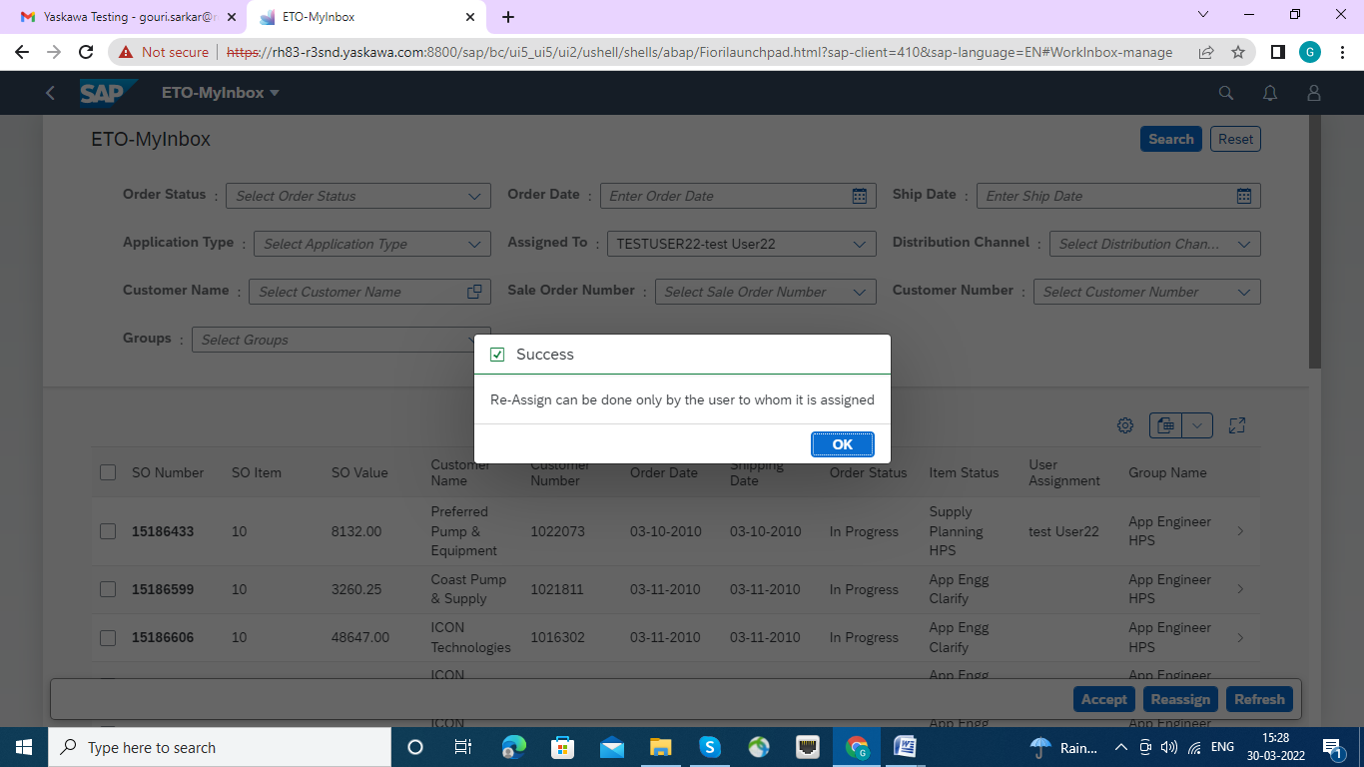

Now, Sales order having with one line Item : 15186626 has been accepted .

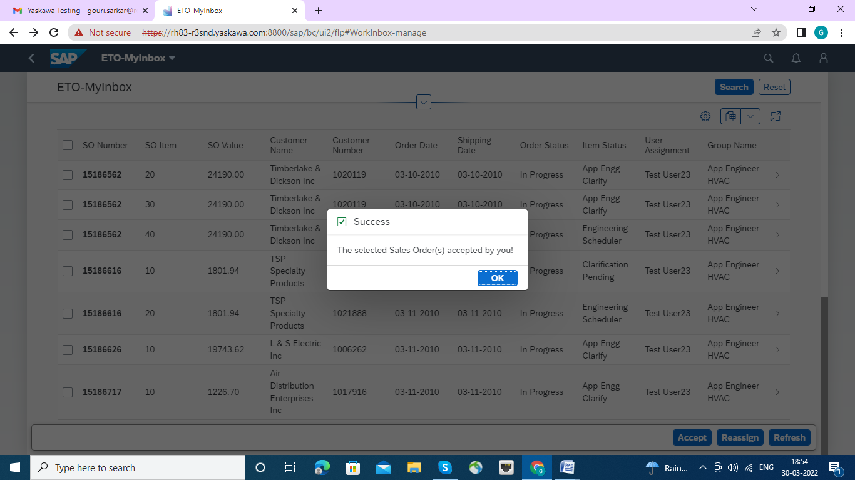

Please click on Accept Button.

**SO Details Screen for Commercial (HPVC)**

**In Application Engineering Section page**

A user assigned to an SO and accepted it will further process the order as below.

As a next step user will double click on the SO to navigate to the detail screen wherein all the details of the selected SO will be displayed in following tabs

* Header Details
* Order Details
* Attachments
* Notes
* Log Details

**Header Details Tab**

All the Header details of the particular SO will be displayed. User can add additional information

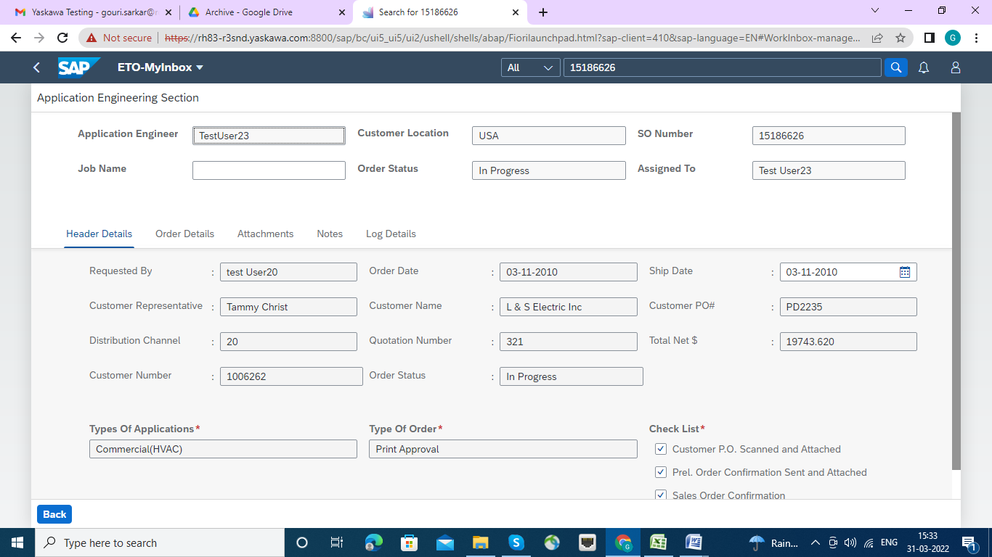

The Job Name filed is being populated here.

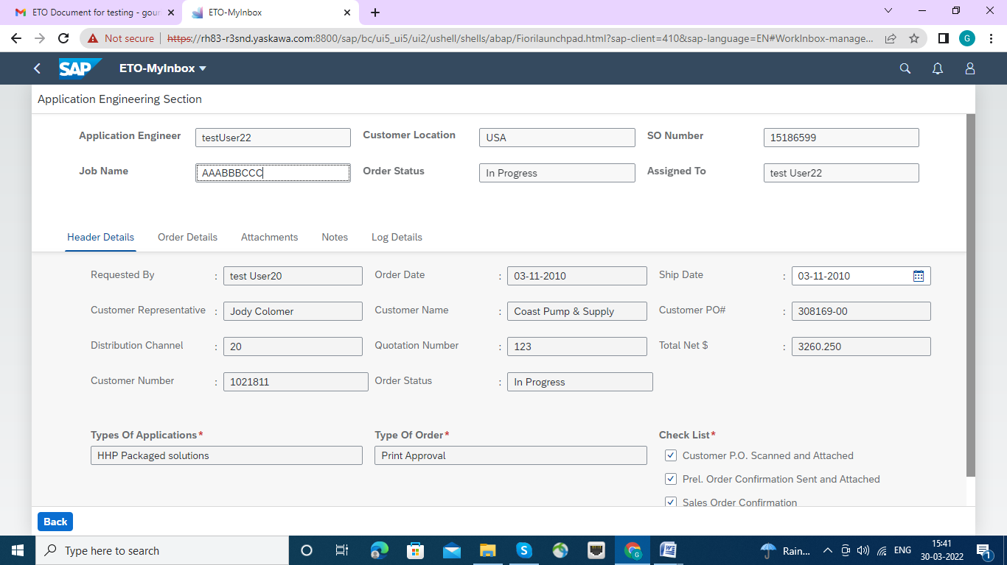

**Order Details Tab**

In the below screen all the line-item details of the selected SO will be displayed

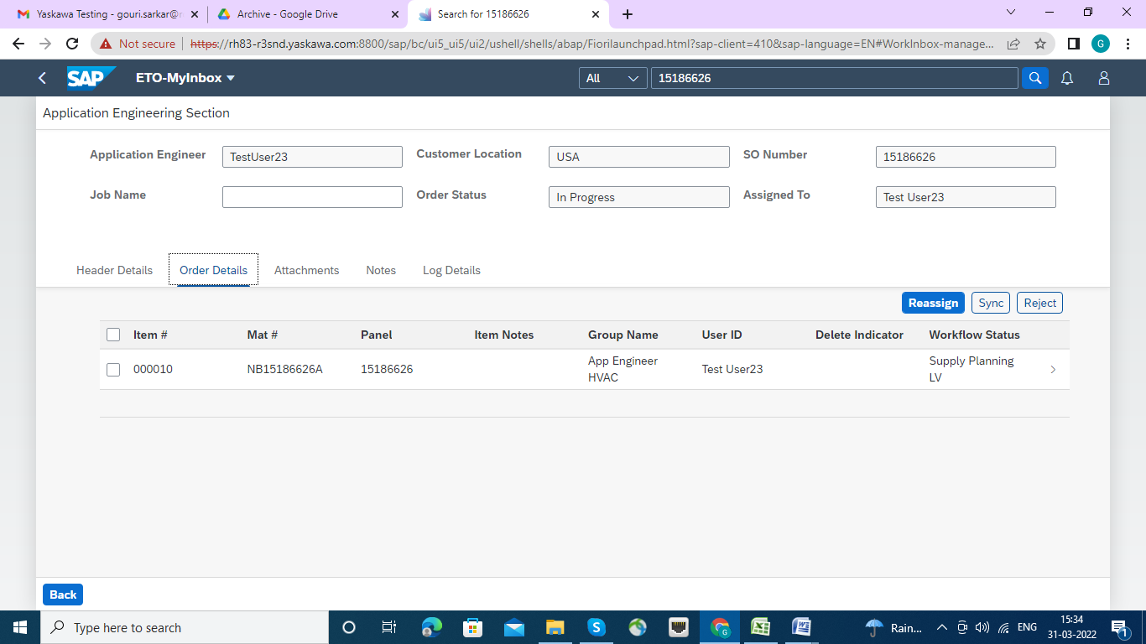

**Attachment Tab**

Attachment tab will show all the attachments for a SO (orginal from sales order, any new added attachments while creating an ETO )

New attachment addition is also possible.

Attachments will be displayed along with history log.

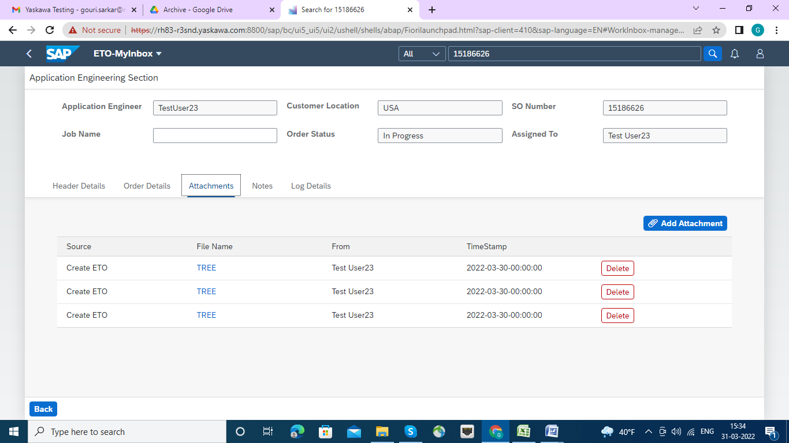

**Notes Tab**

In notes tab will display any added notes at time of creation and new additional notes can be added.

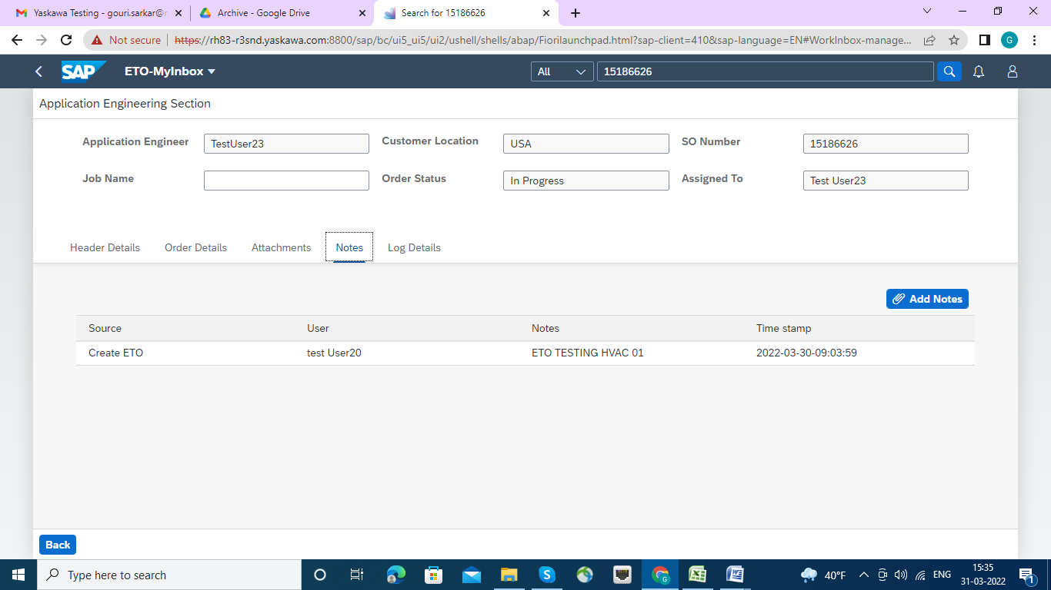

**Log Details Tab**

In log details tab, all the history log for that selected SO will be displayed

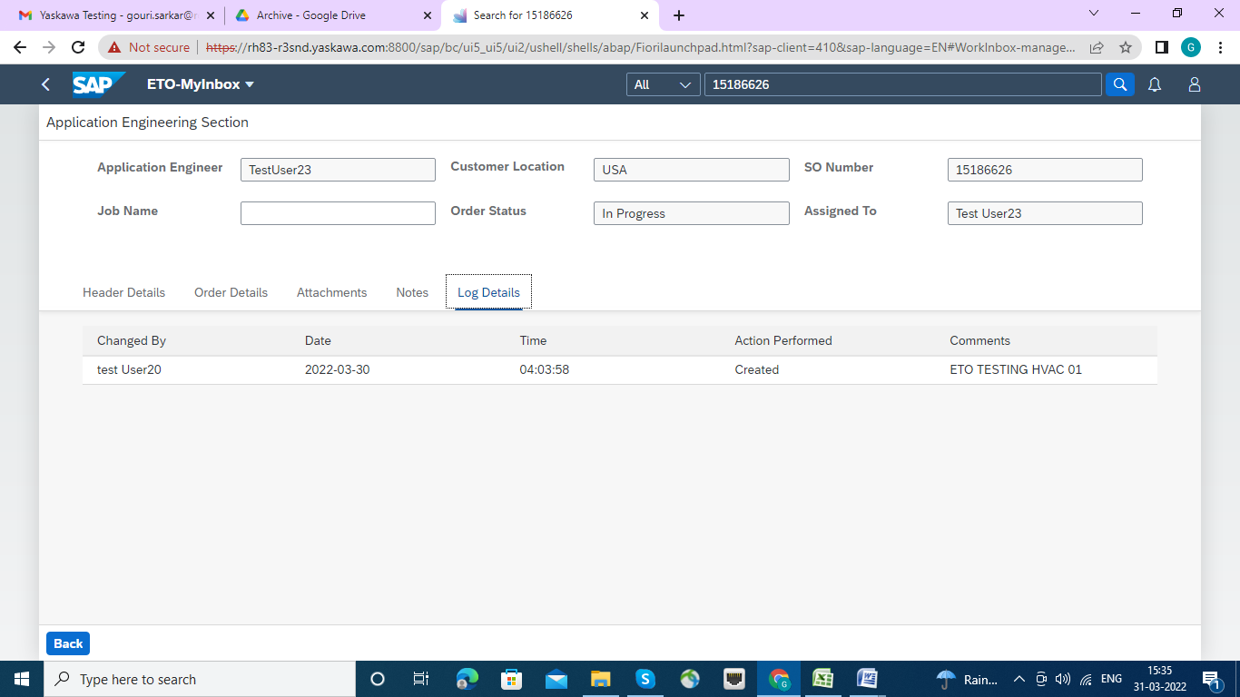

**Now Navigation to detail screen line item wise.**

User will double click on the individual line item and enter the detail screen and double click on Material number .

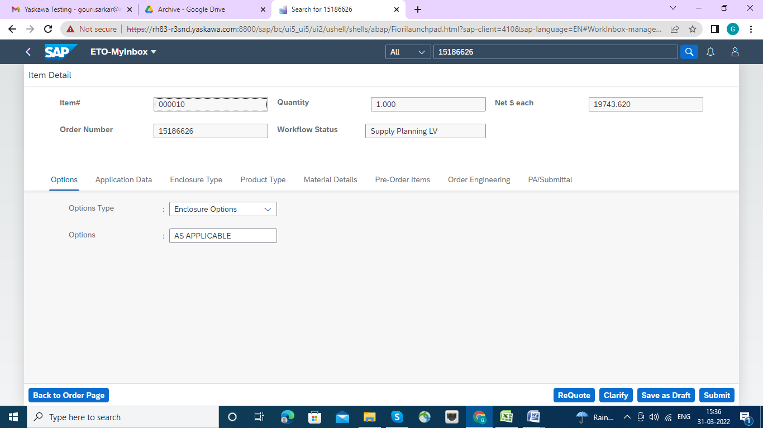

That Double Click on Material Number lead to us in "Item Details “page and Tabs for HVAC Types Order :

There are Eight Types of HVAC Orders and sequential Workflows are assign with.

|  |  |
| --- | --- |
| HVAC Type Order | Work Flow |
| 1.Options | Engineering Schedular |
| 2.Application Data | Supply Planning LV |
| 3.Enclosure Type | Engineering Upload |
| 4.Product Type | Order Engineering LV |
| 5.Material Details | Engineering Schedular |
| 6.Pre-Order Items | MARCOM LV |
| 7.Order Engineering | Complete |
| 8.PA/Submittal | Already Complete |

Each Time after Submission the "Submit Tab” page will back the user to Application Engineering Section, so, every time User will come from **Application Engineering Section to Item Details page.**

HVAC(Commercial) Types Orders:

|  |
| --- |
| 1.Options |
| 2.Application Data |
| 3.Enclosure Type |
| 4.Product Type |
| 5.Material Details |
| 6.Pre-Order Items |
| 7.Order Engineering |
| 8.PA/Submittal |

Click on Option Tab : where Options Types and Options are e maintained by selecting the appropriate Text from Drop down list , as per next screen.

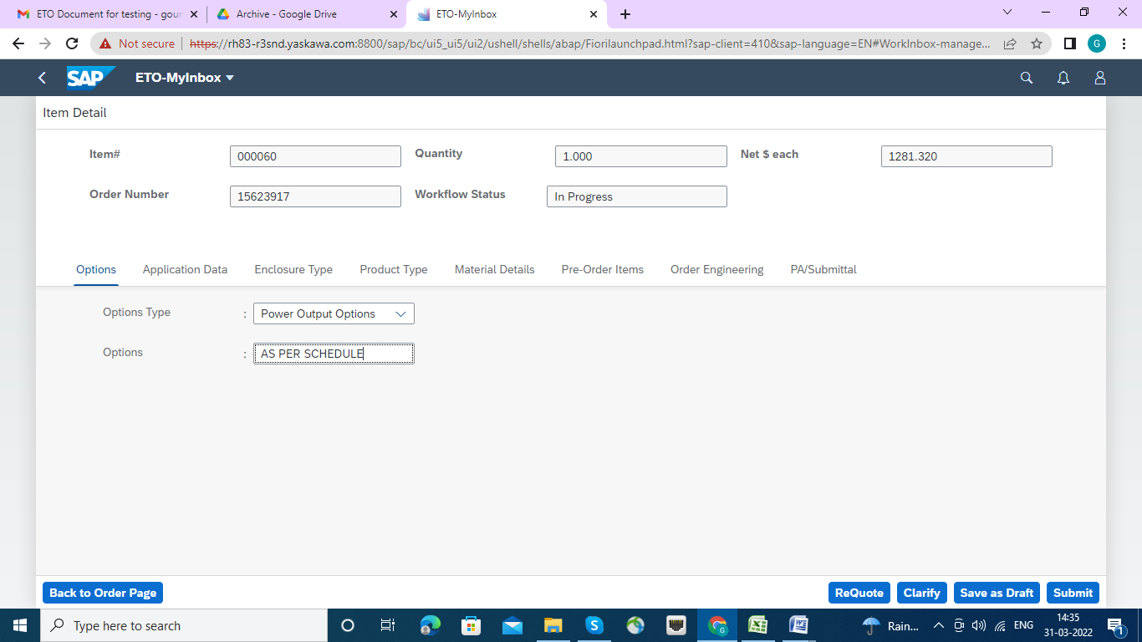

Click on Submit Button:

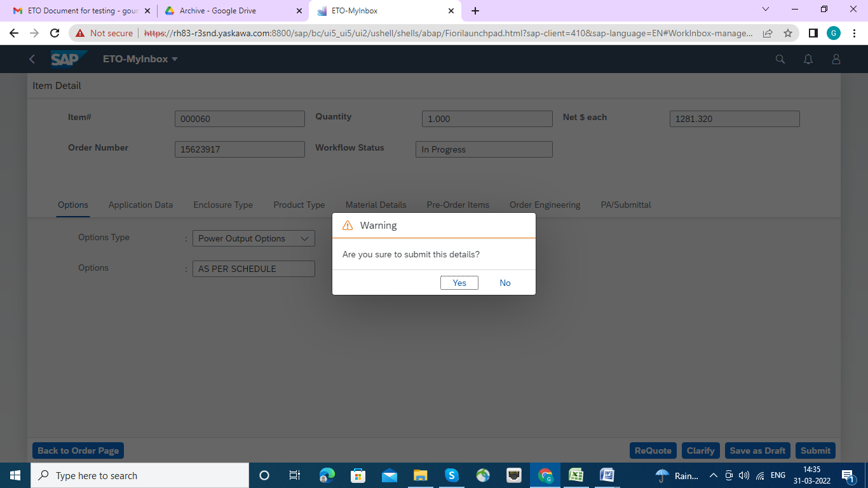

The Click on Submit Tab,

Warning Message has come , if want to proceed to complete click "Yes" Button.



Now the Work Flow Status set to Engineering Scheduler. click ok button.

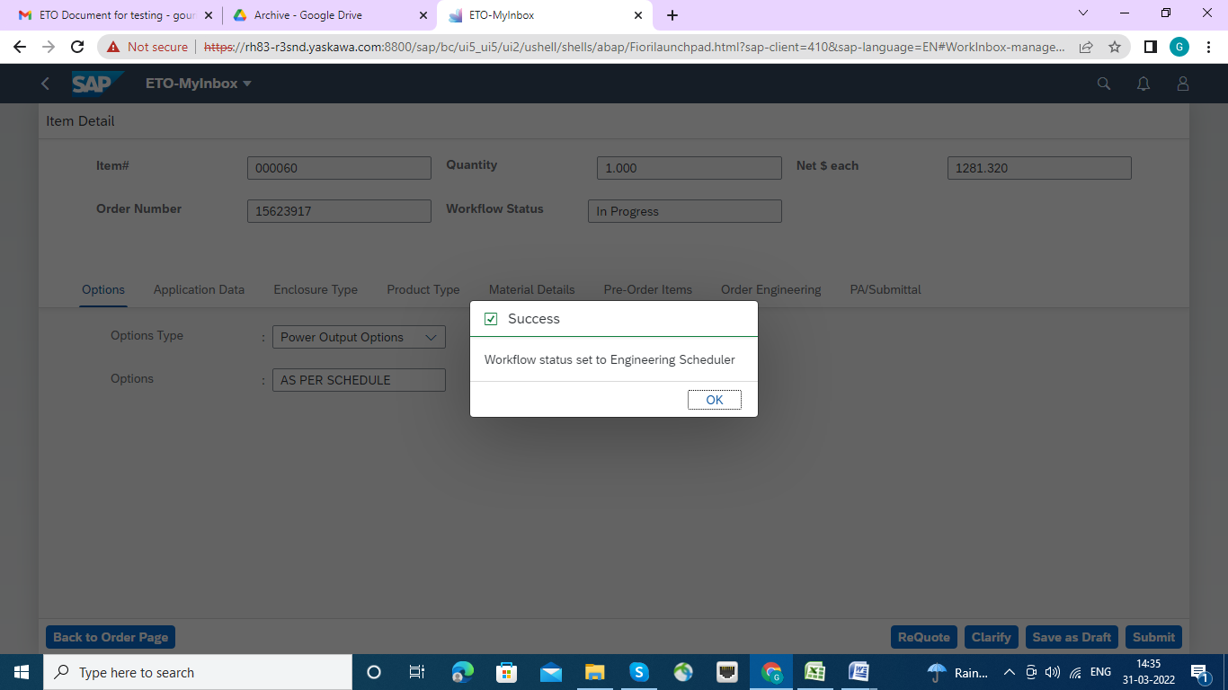

Now click on Application Data Tab, Here all the fields will be populated as per schedule .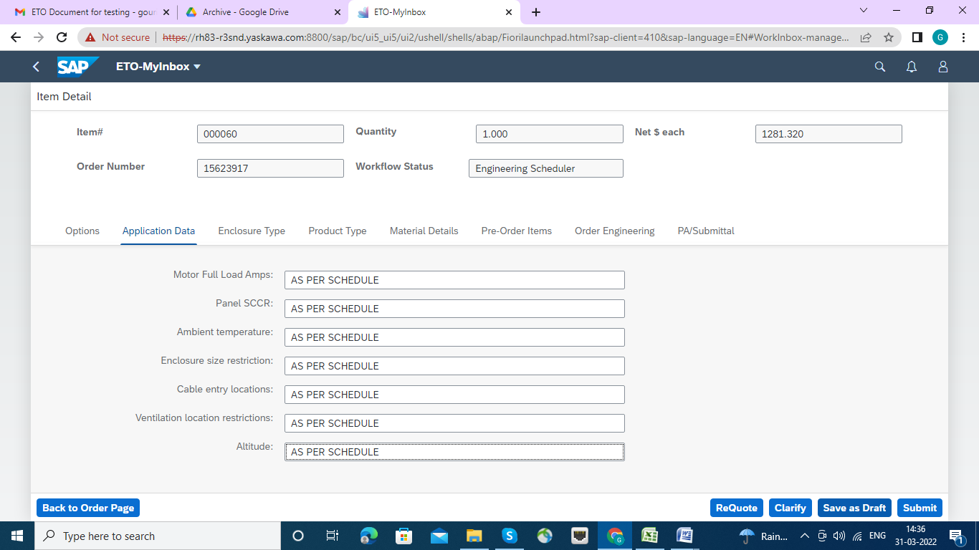

Nest Click on submit Button. This warning message will be appeared, Press Ok Button.

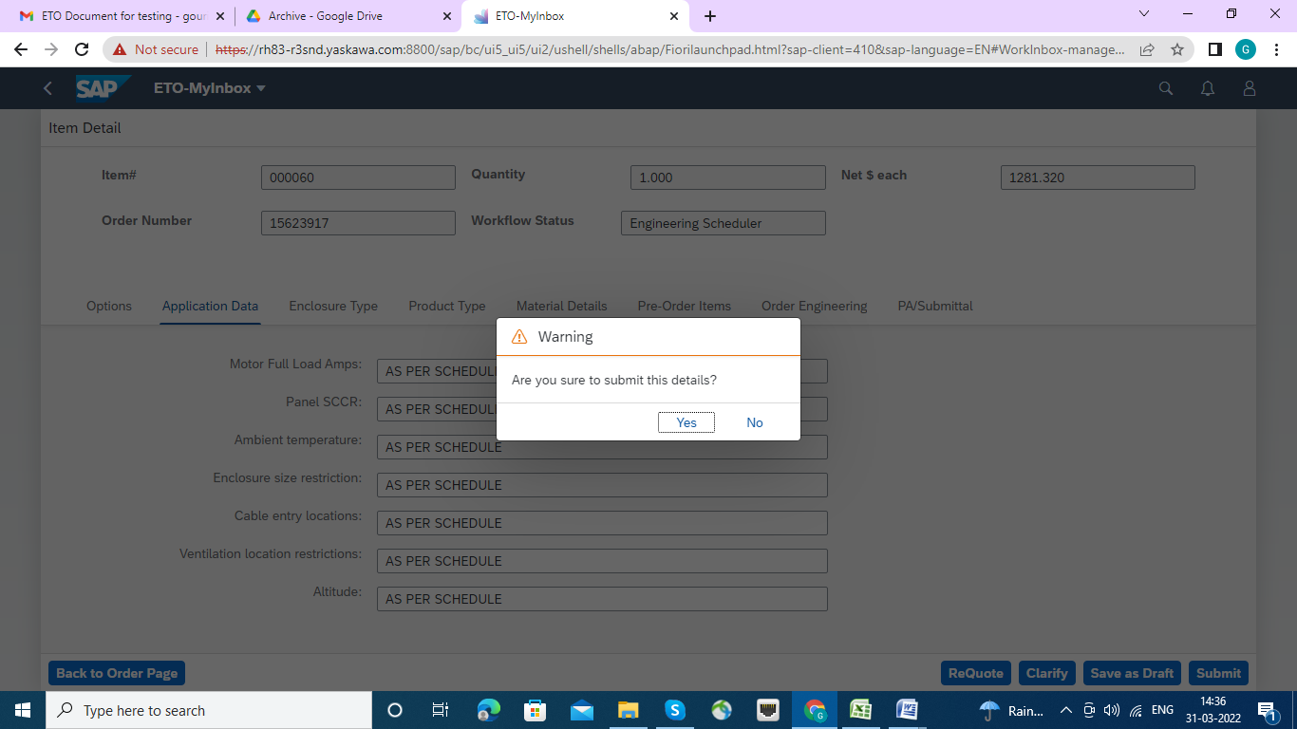

The Success Message will appear, Work flow set to Supply Planning LV. click ok button

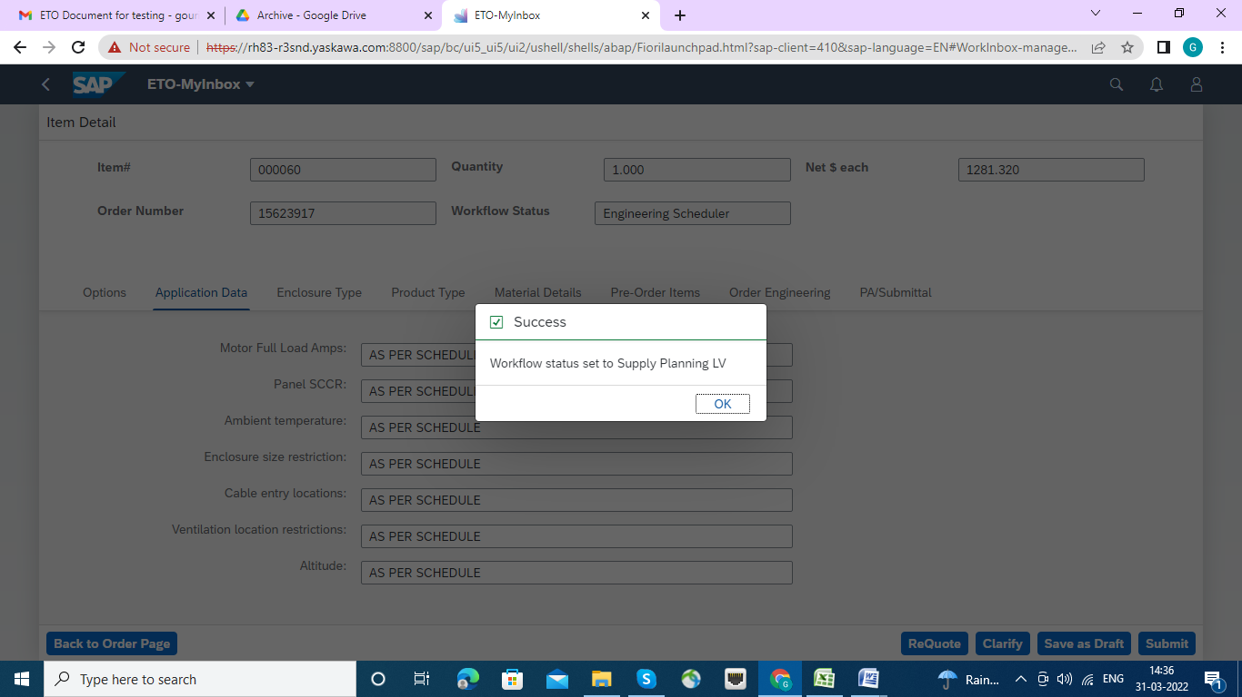

Now Click on enclosure Tab:

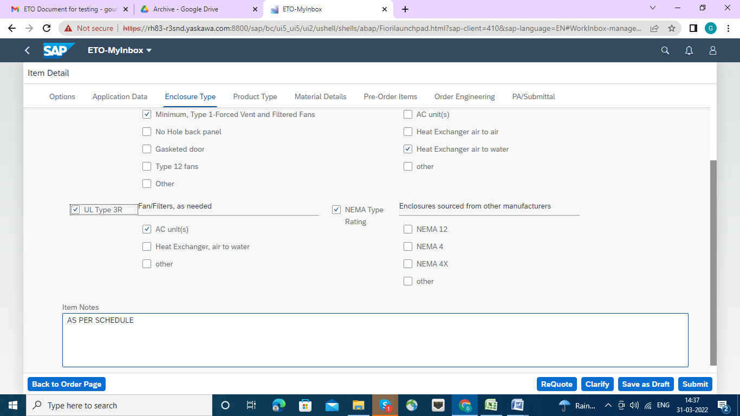

Fill the check boxes with specific data and fill the Item Note and the click on Submit button.

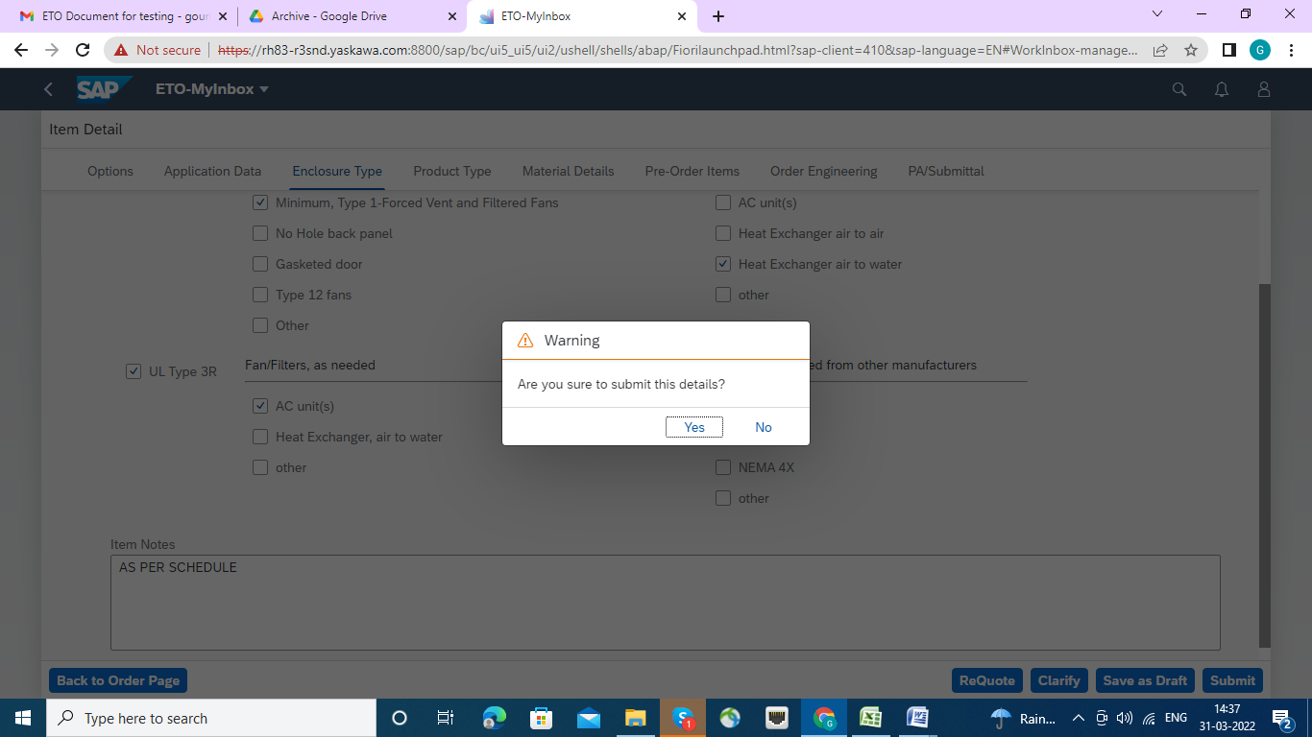

Accept yes button , though it is warning message.

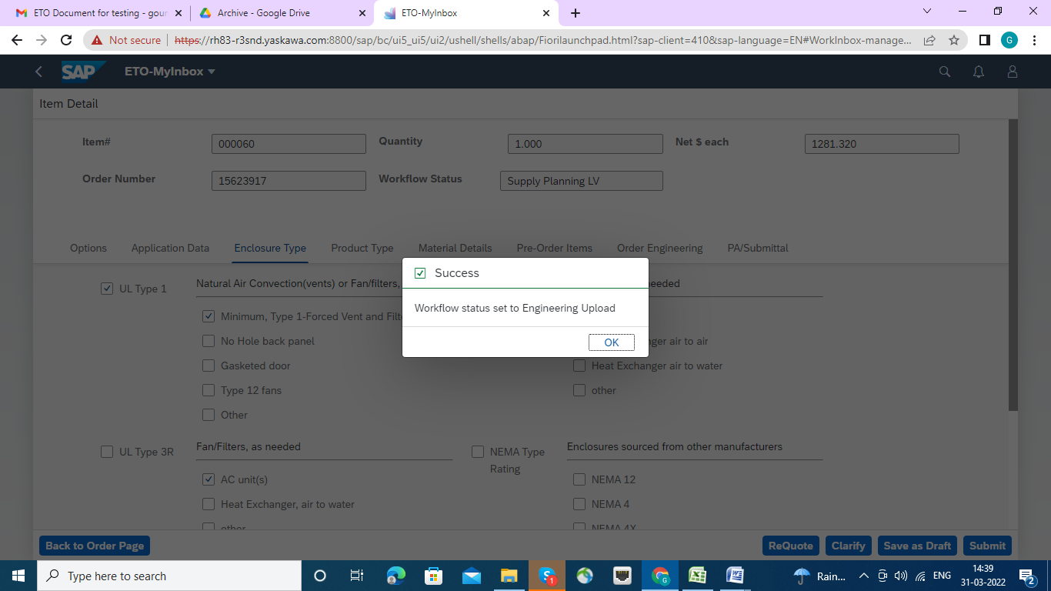

The success status set to Engineering upload. click ok button.

Click on Product Type Tab and fill all the requirement valued by selecting Drop down list,

1. Product type.

2. Over Head Group

3. Strategy Group

4. Product Hierarchy

5. Description.

Then click on submit button

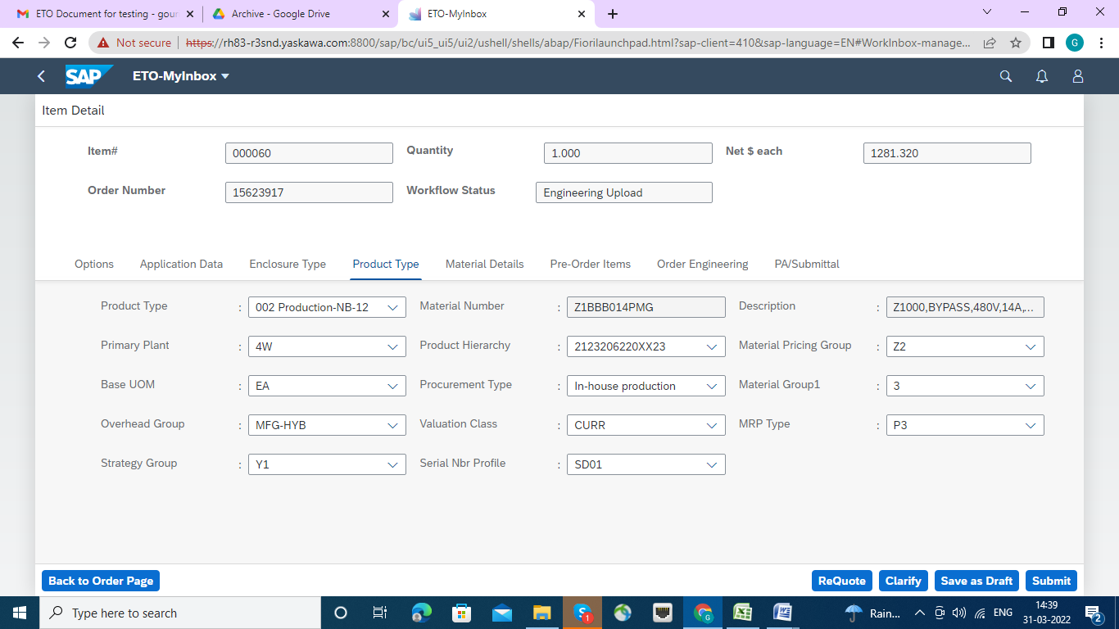

Following screen will come. click yes button.

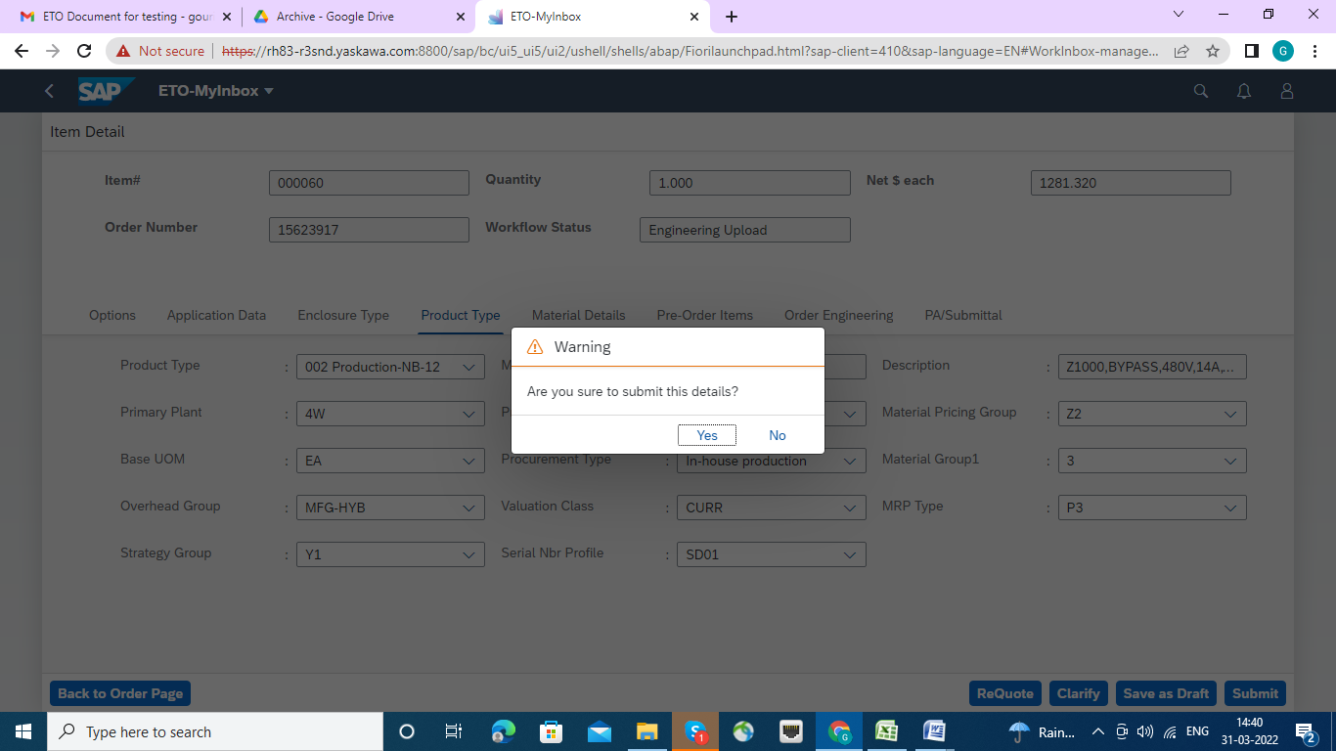

Workflow success message will appear, click ok button.

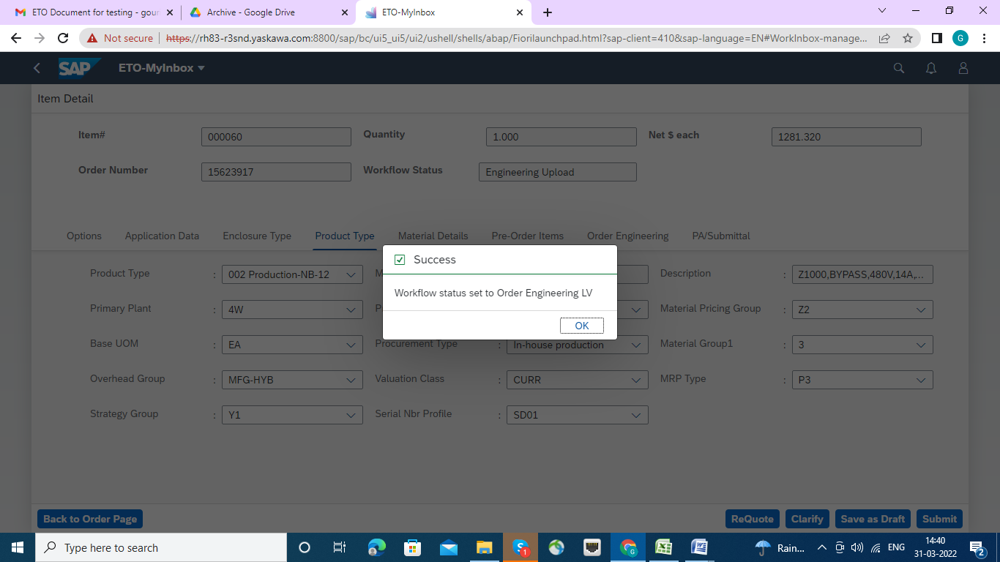

**Now click on material Details tab: fill the appropriate value from droop down list.**

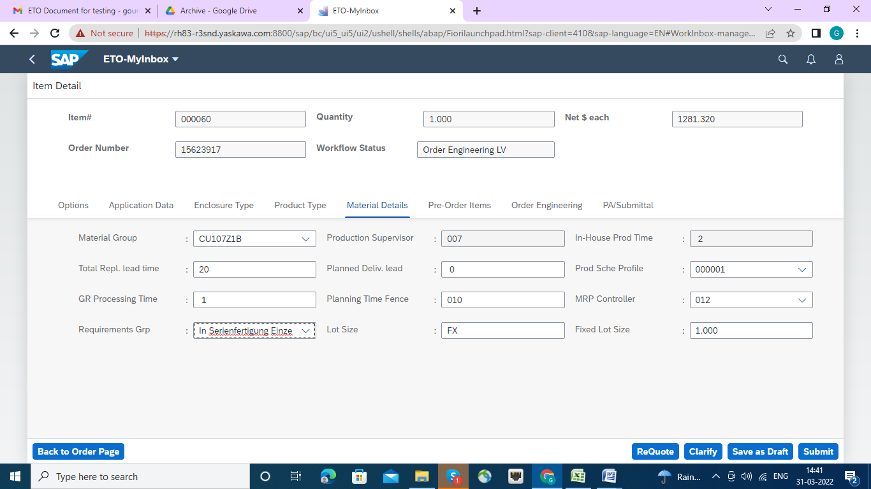

Click submit button. warning message will come. click Yes button.

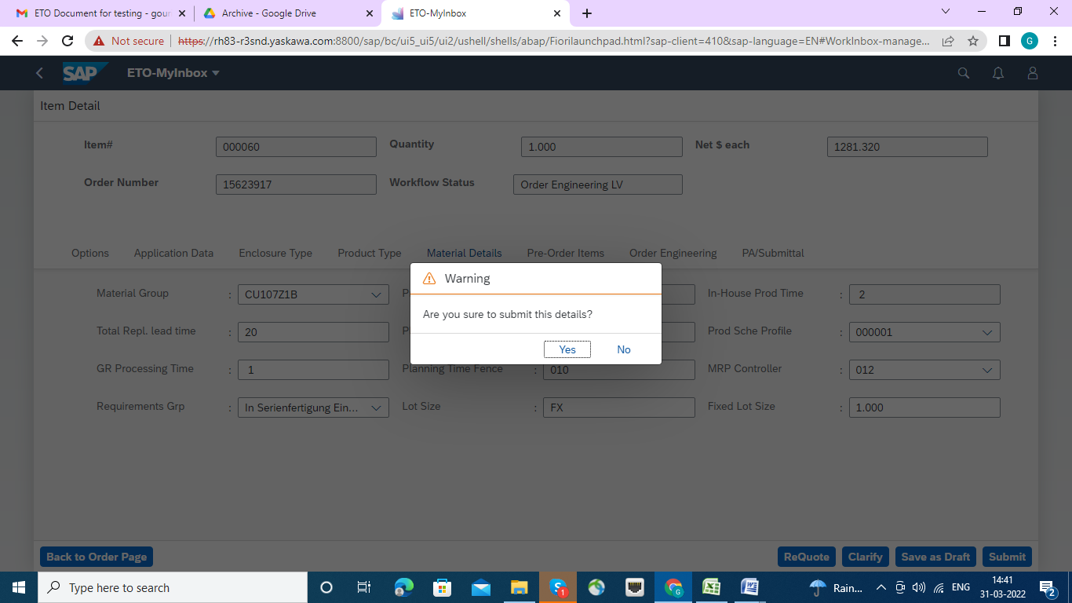

Workflow success message set to Engineering Scheduler will appear. click ok button.

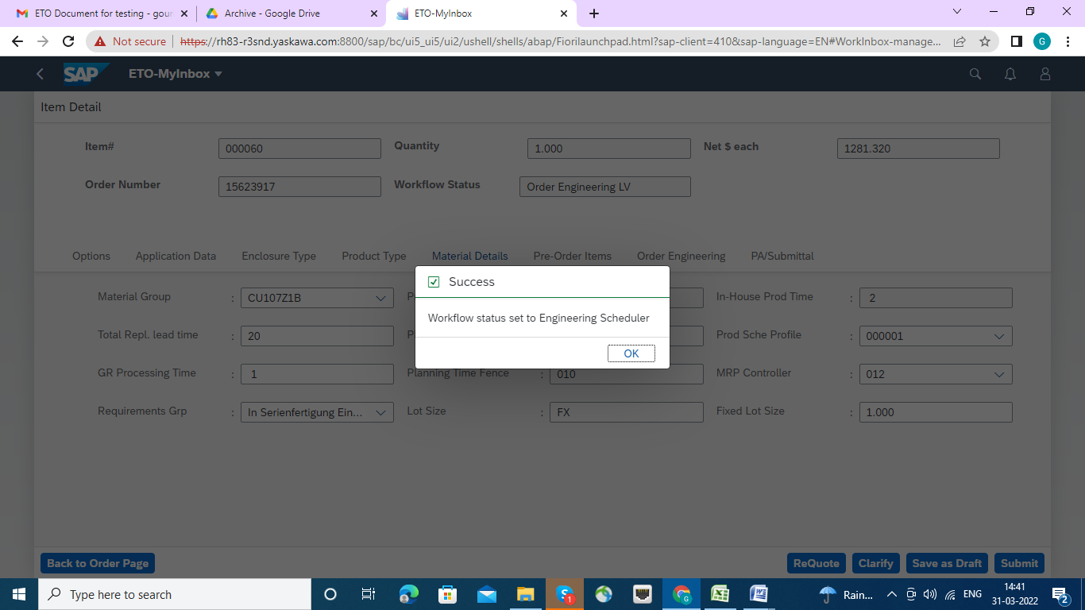

Next click on Pre-Order Items tab.

And fill the blanks as per schedule. and press submit button.

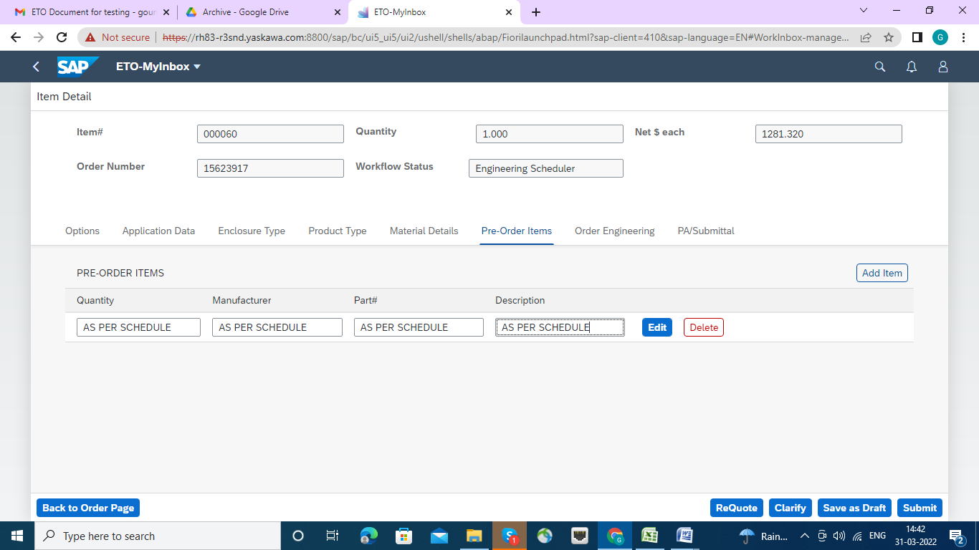

The Warning message will come. click Yes Tab,

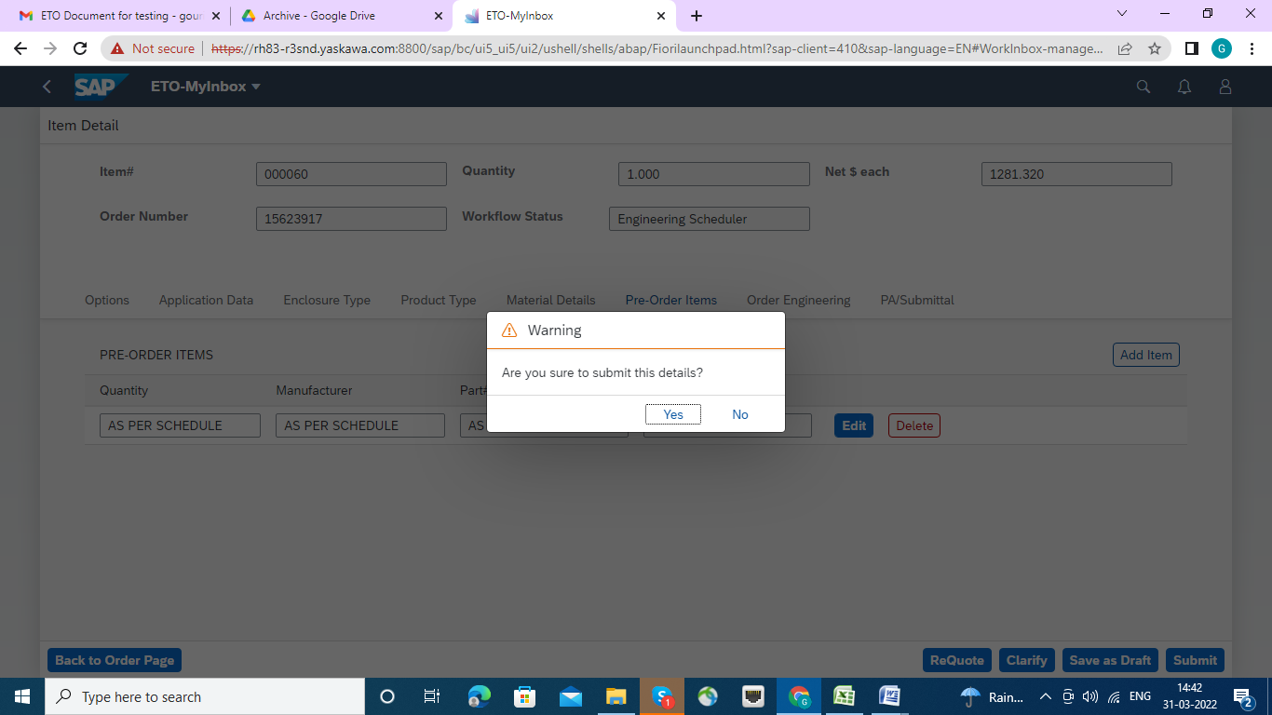

The Workflow success message MARCOM LV will appear. click ok button.

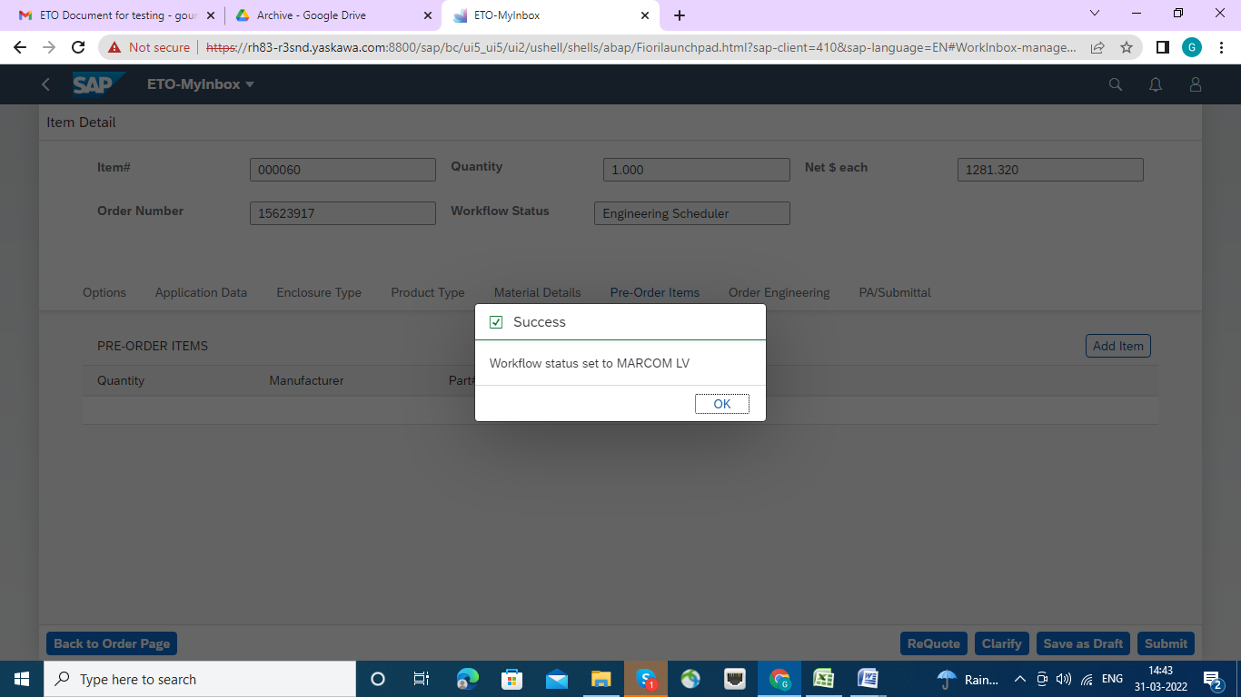

Now click on Order Engineering tab. and fill up all the necessary fields and check boxes. after that press submit button.

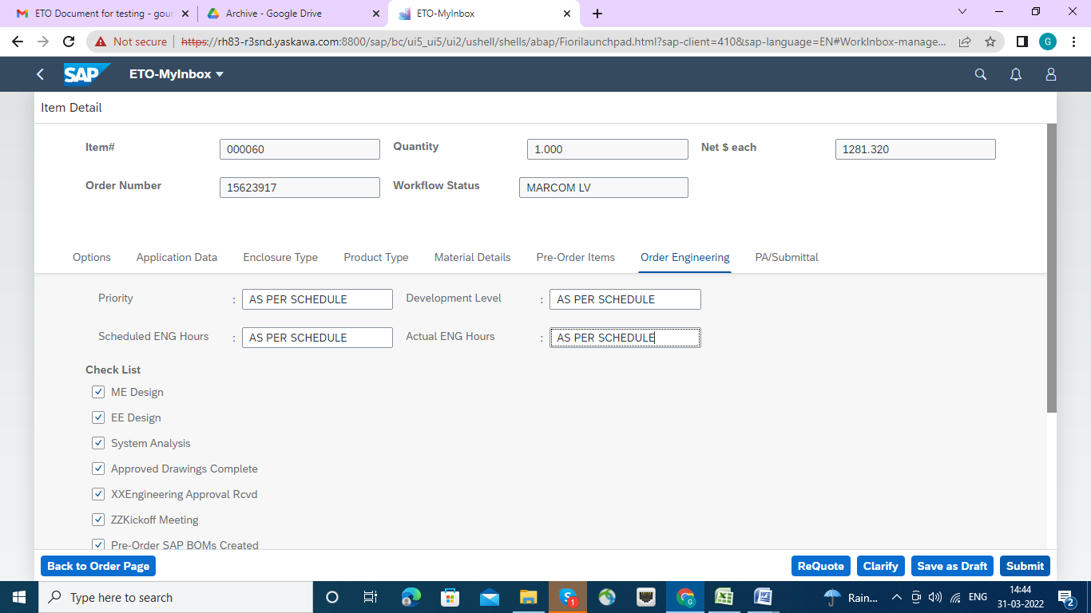

Warning message will appear, press yes tab.

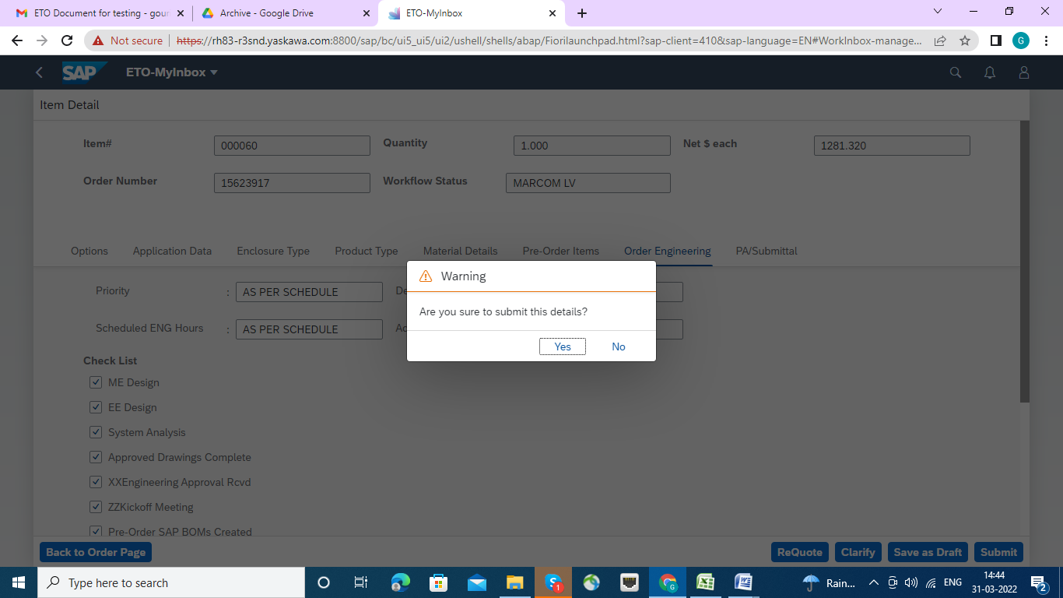

Workflow message Success will be appeared. click ok button.

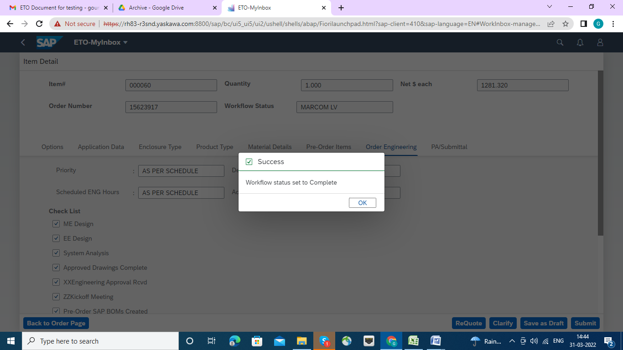

Now click on PA/Submittal Tab: and fill up the text blanks properly and check boxes will also be marked.

Add an attachment if required.

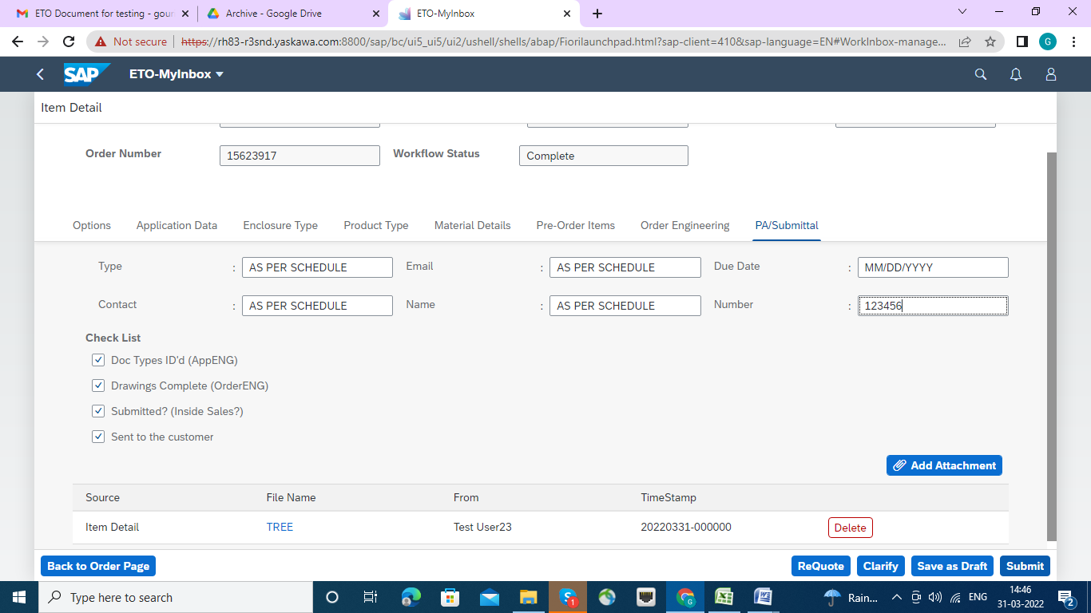

Success fully attachment message appeared. click on yes button.

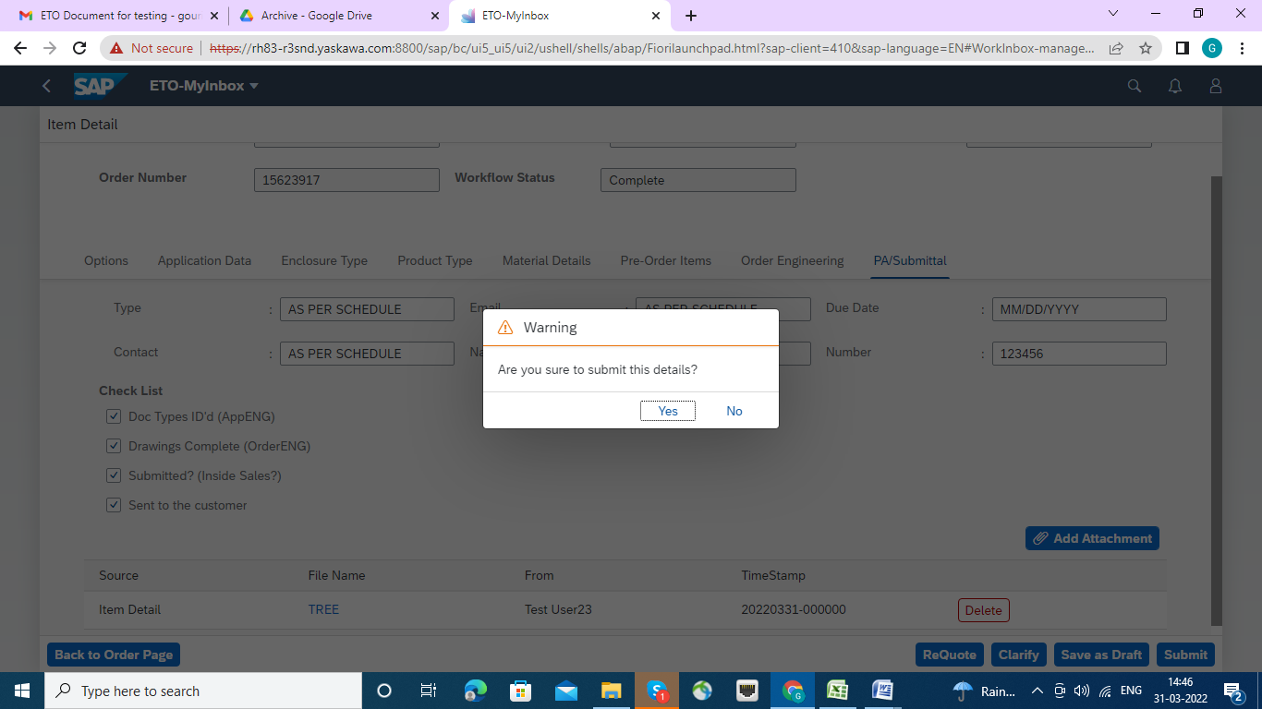

Success message of workflow will be appeared. click ok button.

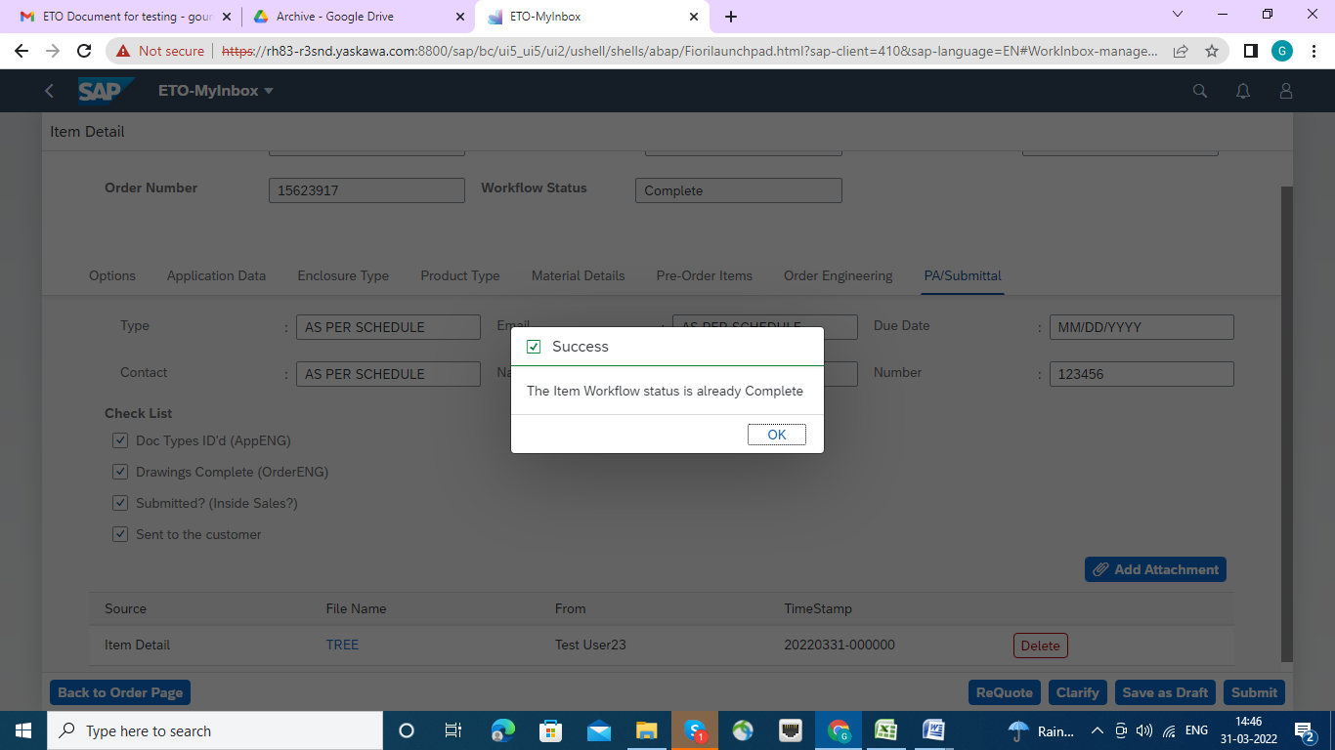

There are Three provisions at any point of time in the processing of the item details

1**. Re quote** : For Modification of Sales Order the Re quote button has to be pressed , Re quote will send mail to the inside sales person/Group who then modify/do necessary action on it. And till Inside Sales person release the Sales Order , further process will be held. Once requote is completed it will be send back to App Engg. Of the particular group

2. **Clarify :** If line Item has to be modify and someone has asked to clarify at any point of time in the processing , then the Clarify will send mail to the application engineer of the particular Group ,who then modify/do necessary action on it. Once App Engg clarifies and submits then it will be sent back to the individual who had raised the clarification to complete his/her steps of processing

3. Save as Draft : any point of time can save as Draft so that user can come back to the screen to complete his/her task

1. Re quote :If it is necessary to Re quote , then press the Re quote Tab, a Text box will appear with Ok and cancel Button. Please input the Text as desired and submitted by OK button. If not required the press Cancel button.

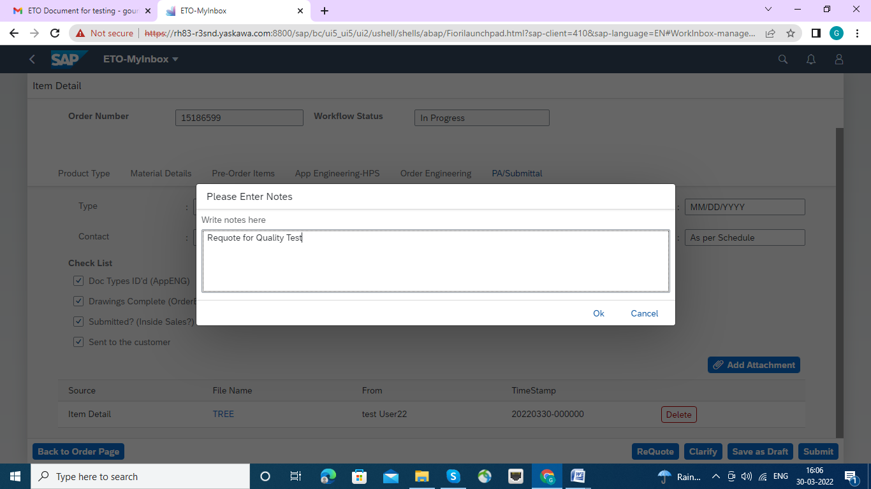

Once re quote successfully done the Success Message will appear.

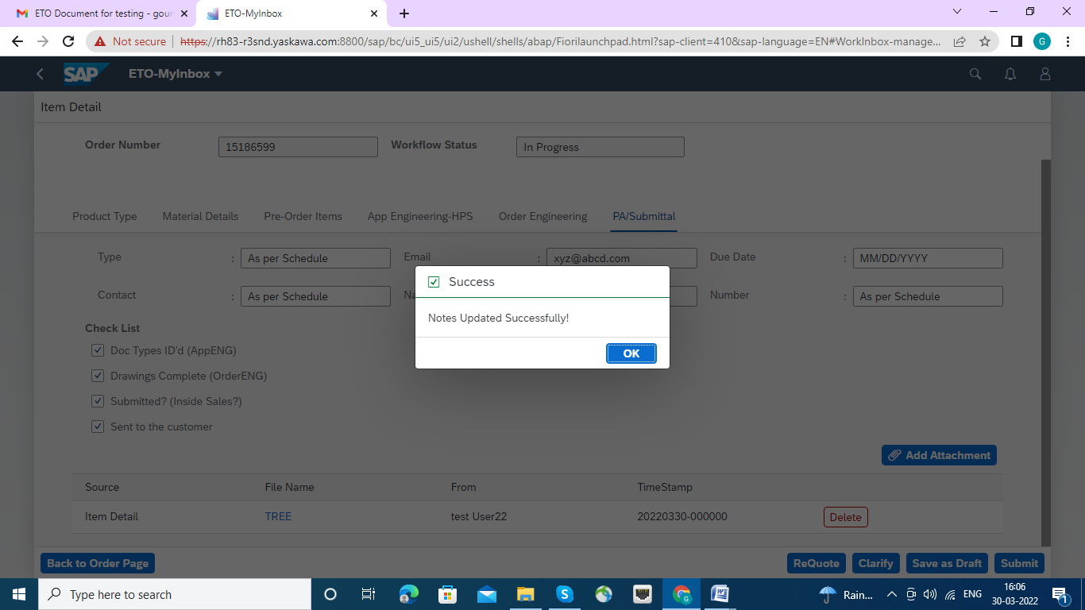

Then press the submit button, the workflow generated to inside sales .

2. Clarify: If it is necessary to Clarify , then press the Clarify Tab, a Text box will appear with Ok and cancel Button. Please input the Text to move ahead as desired and submitted by OK button. If not required the press Cancel button.

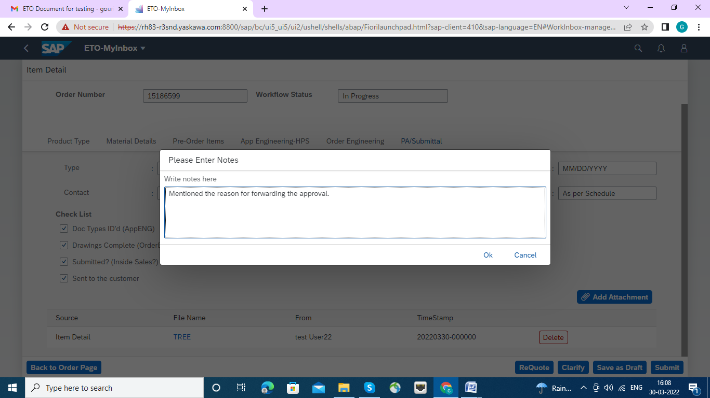

Once Clarify notes is entered successfully done the Success Message will appear.

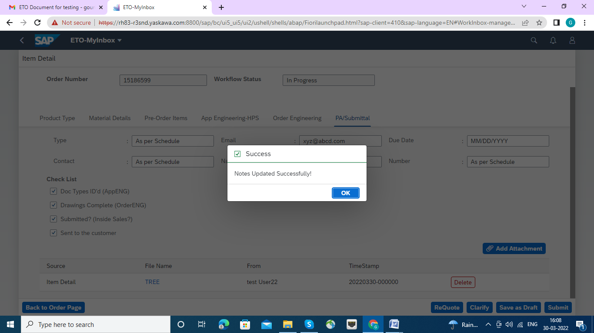

Then press the submit button, the workflow generated to App Engg.

Save as Draft: If it is necessary to Save as Draft , then press the Save as Draft, a Text box will appear with Ok and cancel Button. Please submitted by OK button. If not required the press Cancel button.

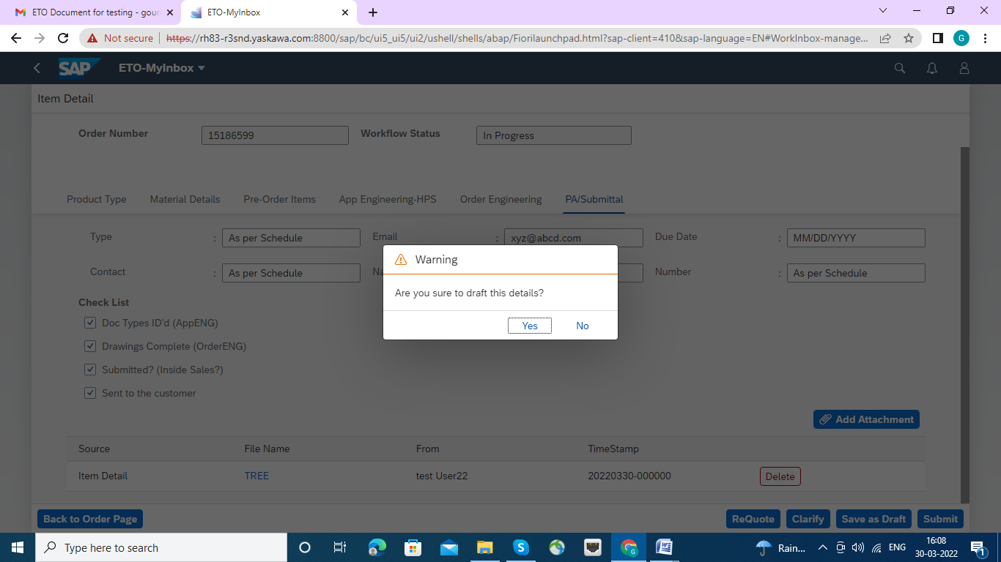

Once OK button clicked the Success Message will appear so that it is saved as Draft.

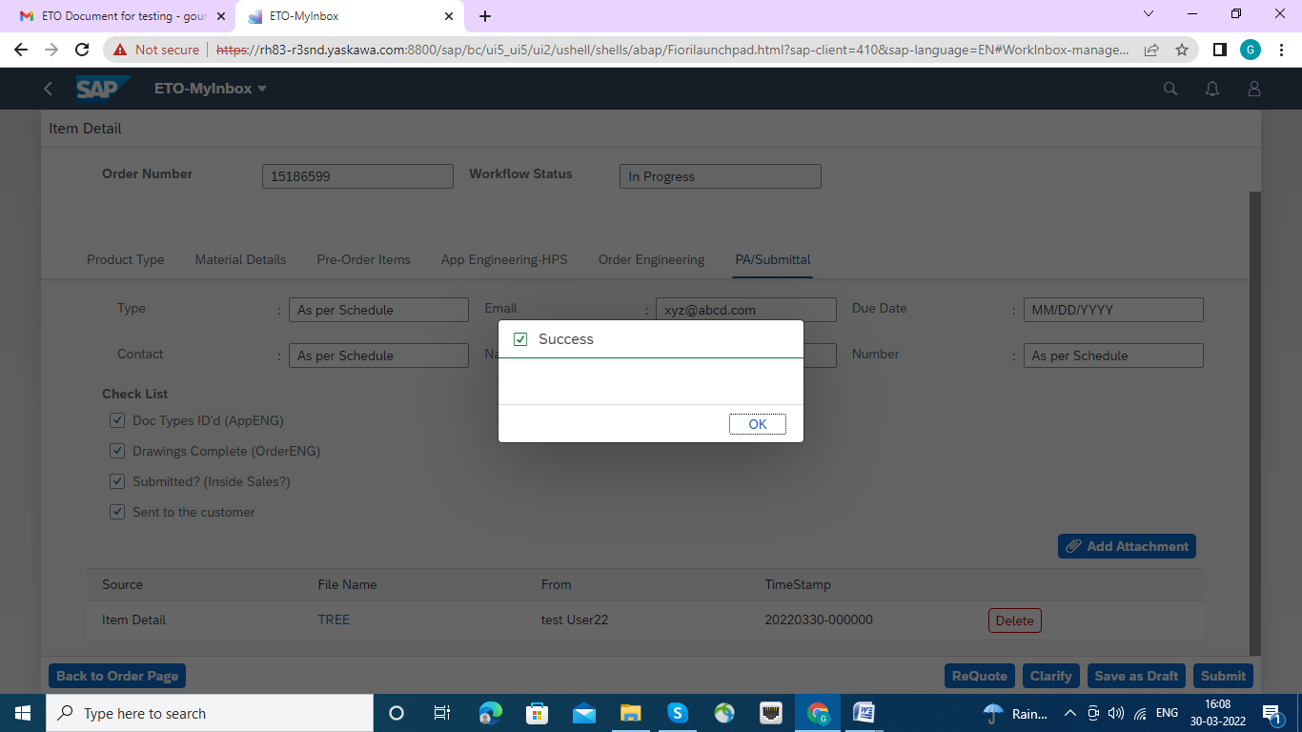

the submit button , the success message will be appeared.